Purchase Requisition
Instructions for Completion
(rev. June 2010)

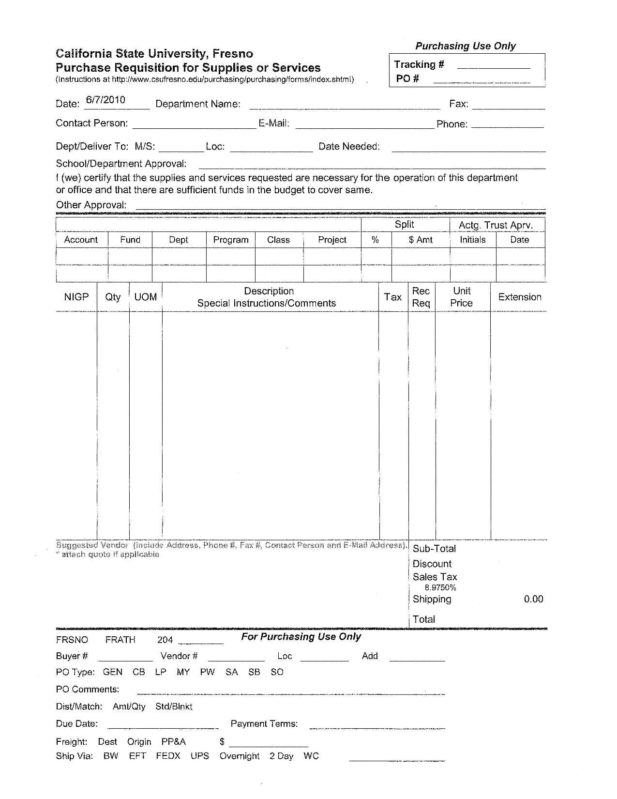
The Purchase Requisition form is used by Campus Departments to request the purchase of goods and services through the Purchasing Office.

Currently, President Welty has directed a freeze on all non-essential expenditures. Only those purchases/change orders critical to the educational mission or operational needs of the University during the current fiscal year should be approved.

Additionally, per the ‘Travel and Expenditure Freeze Guidelines’ issued from the Office of the Vice President for Administration, all requisitions greater than $2,500 must be approved by the Director/Dean with written justification forwarded to the Provost/Vice President for approval. Requisitions received at the Procurement Department without the appropriate authorizing signatures will be returned to the Department for additional signature(s).

Quick Reference Chart
When do you need it?
Leave this box blank
Departmental Contact Person/Email/Phone/Fax
Authorized Department Signer
Auto-dated by Informed Filler
Authorized Administrative Signer – VPA, Provost or their designee
Enter Discount and Shipping Cost; other fields in this box will self-populate.
Extended Price = Unit Price x Qty
List the Unit Price
Is Receiving at the warehouse required? Y or N
??????????????????????????
Is the item/service on this line taxable? Y or N
If funding is from a Trust Account, approval must be initialed & dated by Accounting.
If split funded, list % and & for each fund here.
Desired Vendor Contact Information here (name, phone, contact, fax, email)
Detailed Description of goods/services needed
UOM = Unit of Measure (each, lot, pair, dozen, etc)
Leave NIGP column blank
List quantity of items needed.
Fill in Account, Fund, Dept, Class and Project where invoices received are to be paid from
Where is product to be delivered, or service to be performed?
Department Name
Leave all information below the dark line blank.

Detailed Instructions

5
4
3
2
1
17
8
7
6
9
21
16
22
15
14
13
12
11
10
18
19
20

Date: Informed Filler will populate this field for you automatically with the current date.
1

Department Name: Type in the name of your Department,
2
Division, or Unit name.

Type in the name of the person to be contacted if there are
3
questions regarding the information on the requisition. Provide contact name, email, fax and phone numbers. NOTE: you must provide only the prefix of your email address: example - busyworker@csufresno.edu would be listed as busyworker.
4
Purchasing Use Only: Leave this field blank.

Date Needed: Type in the specific date when the product must be delivered or the service must be performed. Ensure that the date listed is within a reasonable amount of time. For example, ‘tomorrow’ is not within a reasonable amount of time. You will be contacted if this date can not be met.
5

Have an Authorized Signer from your Department sign here.
6
To determine who the Authorized Signers for your Department are, please contact the Procurement Office at 278-2111.

Per the “Travel and Expenditure Freeze Guidelines” issued from the Office of the Vice President for Administration, all requisitions greater than $2,500 must be approved by the Director/Dean with written justification forwarded to the Provost/Vice President for approval. Requisitions received at
7

the Procurement Department without the appropriate authorizing signatures will be returned to the Department.

If the Chartfield Coding is from more than one source, use this space for indicating the percentage (%) and amount.
8

If the Chartfield Coding is from a Trust Account, approval (initials and date) from Accounting must be provided in this space prior to delivery to Procurement.
9

On each line on the requisition, enter a “Y” or “N” in this column indicating that the item or service is taxable “Y” or non-taxable “N”.
10
11
Leave this field blank.

Each line item must have a corresponding Unit Price which should be found on the Vendor quotation. Enter that Unit Price in this column.
12

Each line item must also have a corresponding Extended Price. Extended Price = Unit Price x Quantity. This field will be autopopulated after the Unit Price and Quantity have been entered.
13

This section is comprised of five elements. Users are required to complete only the Discount, and Shipping fields. The discount and shipping cost may be entered using only dollar figures, not percentages.
14
15
Leave all information below the dark line blank.

List the desired Vendor and their contact information here. Include the company name, contact name, address, phone, fax, and email if available.
16

Provide a detailed description of the goods or services needed. Include Model Names, Model Numbers, Colors, Dimensions, Performance Expectations, Part Numbers, and any identifying information that will assist the Buyer and Vendor in determining the best price for your needs.
17

Provide a UOM – Unit of Measure. Units of Measure include package, hour, day, lot, each, job, page, copy, pair, dozen, etc. Refer to the price quotation if necessary to determine how the vendor quoted your goods or services.
18
19
Provide a quantity for the product or service you need.

20
Leave this column blank.

Fill in the Chartfield Coding for your purchase. Identify the Account, Fund, Department, Class and Project where invoices received against the purchase order should be paid.
21

Provide a delivery location where the Warehouse, or Vendor, should deliver your goods or services.
22

*Special Note: Department is not required to obtain multiple quotes for goods and services. One vendor quote is sufficient for budgetary and Requisitioning purposes. This does not apply to Public Works.

