Revolution or Evolution? The Armenian Book from Manuscript to Print
Dickran Kouymjian
Paper presented on November 10, 2012 at UCLA conference:
Port Cities and Printers: Five Centuries of Global Armenian Print

I. Premise of a "Revolution"
The mid-fifteenth century innovation of making books in multiple copies with movable type, the Gutenberg revolution, introduced a radically new technology. Though the mechanical aspect of book production experienced a revolution, it did not change the physical aspect of the object. A book looked the same and was read in the same way before and after Gutenberg; there was no way to distinguish a manuscript from a printed text unless you opened it. This was not the case with an earlier revolution in book making: the rather rapid shift from the papyrus roll to the codex consummated in the fourth century. The scroll had to be unrolled and read a section at a time; the codex with folded pages permitted quick movement within the text. Neither is it the case with the digital revolution, where the object itself, the e-book, disappears if the Internet connection is cut; furthermore, there is no material item to store, thus no need for brick and mortar structures to house electronic books. In this respect the revolution in our time can be viewed, cynically perhaps, as the disappearance of the codex-book and with it, libraries.
In questioning the notion of revolution associated with Armenian printing, one should also reflect on the long period from the first Armenian book of 1512 to the triumph of print over manuscript two and a half centuries later. Such a gradual transformation does not evoke a revolution but rather an evolution.
II. A. The Sixteenth-Century Crisis in Manuscript Production
In a statistical study of Armenian manuscripts published in 1983, I pointed out the sharp decline in production in the early sixteenth century, the very moment Hakop Meghapart began the Armenian printing adventure. Based on catalogues of some 17,000 Armenian manuscripts and relying only on 9,500 dated codices, a simple graph was plotted showing that in the sixteenth century for the first time since the earliest surviving Armenian manuscripts of the ninth century, the level of production fell below that of the previous century. 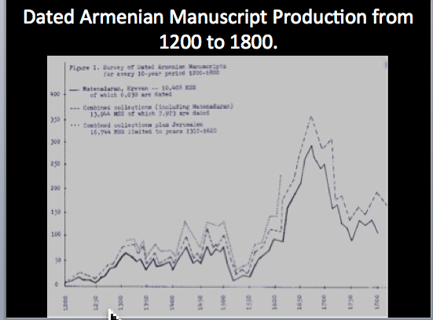
The decline is palpable: from our sample, 593 dated manuscripts date from the fourteenth century, 832 from the fifteenth, but only 627 from the sixteenth. By contrast, there are 1,250 from the first fifty years of the seventeenth century and 2,750 for all of it. To underline this production crisis, the first two decades of the sixteenth century show the severest drop in manuscript production ever recorded and for the first time, in our sampling, there are four years with no manuscripts recorded, virtually an unknown phenomenon in the centuries before and after.
The graph also shows a steady rise in production starting in the 1550s, and even more dramatically after 1610, to reach an absolute historic high during the decade ending in 1660 after which there is a gradual, not a sharp, decline until the end of manuscript copying in the nineteenth century.
In view of these data, how then does one tell the story of Armenian printing? What could the act of printing have meant to those actually producing the books? Did the printers know about the vertiginous drop in manuscript production or were they simply trying to master a new technology? Was it an adventure in using a new method of book (re)production for expanding literacy and knowledge among those who read Armenian? Or was it a purely entrepreneurial experience, an attempt to succeed at something? Such questions need to be asked.
II. B. Did Early Book Printing Relieve the Manuscript Crisis?
Since the statistical high in manuscript copying is in the decade before the most significant early Armenian printing venture begins, that of Voskan Erevanc‘i in the 1660s in Amsterdam, with a cumulative press run of the half dozen titles in that one decade of some 10,000 individual books, including the first printed Bible in Armenian of 1666-1668, one would suppose that copying manuscripts hand would stop. But this was not the case. It was only a hundred years later, in the second half of the eighteenth century, thanks to 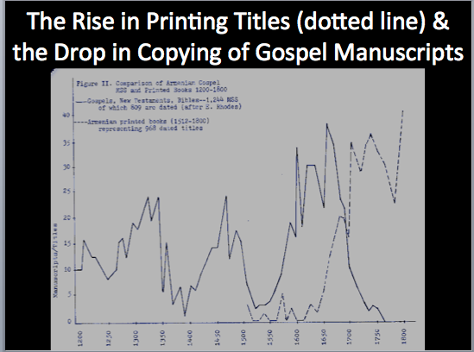 the aggressive publication of Gospels, Hymnals, Psalters, and other religious titles in Constantinople and Venice that the manual production of Gospels and other religious texts comes to a halt. This suggests evolution rather than revolution. The reasons are many; perhaps the most important is that the cheap or free labor of monastic scribes was still more economical to the church than the purchase of expensive printed books from Constantinople or the more distant Venice or Amsterdam.
III. The Real Revolutions
Nevertheless, revolutions in domains other than production of books can be postulated by radical changes in the organization, the design, the reading, and the contents of books. Below, I will try to conceptualize a number of formal transformations: the geographical change of production, no longer in Armenia but in a diaspora, essentially European; the environment of production, no longer the religious confines of the rural monastery with clergymen as scribes, but an urban one often with laymen as laborers; the structure of the book, from titlepage to subject matter; the content, embracing more secular subjects as supplement to traditional Christian texts, eventually outnumbering them.
A. Geography. The book from its fifth century inception to the fifteenth century was almost entirely produced in historic Armenia. It is true that some manuscripts were written abroad, Adrianople in 1007, Egypt in 1099, a group in thirteenth-century Italy, and Cilicia, though the latter can be considered an extension of historical Armenia. Starting in the fourteenth century, the Crimea becomes a major center of book production, spilling over in the following century into central Europe, especially Poland and the Ukraine, as Armenians moved inland and west after the Genoese lost the Crimea to the Tatars and Ottomans. But these are exceptions and together, including manuscripts produced in Western Anatolia towns, they make up only a small percentage of hand-written codices.
B. Environment. Those directing Armenian printing in its first centuries were clergymen, this was not the rule among Europeans, though Protestant and Catholic authorities were powerful factors in the development and the control of the new industry. Labor in Armenian printing offices was often the work of laymen. Furthermore, Armenian print shops were not attached to monasteries, but usually occupied commercial premises or were in private homes or occasionally attached to a local Armenian church. In Armenia proper, however, book production was the prerogative of the monastery or local church and at precise historical moments, royal or aristocratic scriptoria. Manuscripts were produced exclusively by the clergy. The formation of a corps of secular scribes in late medieval Europe, due in part to the rise of the great universities like Paris and Bologna, had no counterpart in Armenia.
In this sense Armenian printing was revolutionary, moving from the rural often isolated monastic setting to the print shop, usually secular establishments, almost always in an urban environment. The exceptions are the church authorities in Lvov and New Julfa in the seventeenth century and the Mekhitarists a century later; yet even in these cases, though monastic establishments, they were in important cities.
C. Structure and Format. As mentioned above, in the first 250 years of the Armenian press, the look of a bound manuscript or a printed book was the same. Since the codex was the form used in printing, the folding of sheets into quires and their sewing into a single block was identical to the method of binding manuscripts, following the folio, quarto, and octavo formats employed long before Gutenberg. Thus, it should be no surprise, though today perhaps strange, that in monastic libraries printed books were shelved together with manuscripts; furthermore, it was not uncommon to find a printed text bound together with a manuscript. Though printing resulted in mass production of texts, uniform binding techniques only developed centuries later, in the Armenian case in the late eighteenth century. I have suggested elsewhere for scholars or clergy, there was a certain indifference to whether the desired text was a manuscript or one set in type.
Once the book was open, the difference was clear and often dramatic. Printing created uniformity in page layout, text size, pagination, and, perhaps above all, the formation of a titlepage, absent in the first Armenian books of Hakob Meghapart. 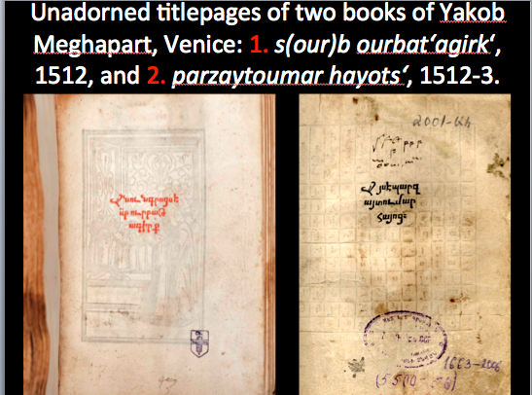 Already among incunabula (books printed up to 1500), the decorative titlepage appeared, eventually with an elaborate architectural structure within which was incorporated the title, the names of the author, patron, and printer and the place and date of publishing, information traditionally included in the scribal colophon at the end. Armenian printers borrowed this new mode of a titlepage, often framed in a monumental arcade.
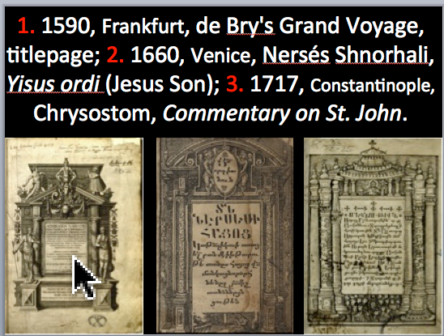 Innovations resulted in major changes, for instance to the Gospelbook, the most copied text among Armenian manuscripts. In the first two centuries Gospels were rarely printed, except as part of the Voskan Bible of 1666. The well developed layout of text and illustrations of Gospels was of little use to that chosen by printers. Once Gospels were printed in large numbers in the eighteenth century, finally putting an end to monastic copying, their layout was modified. For 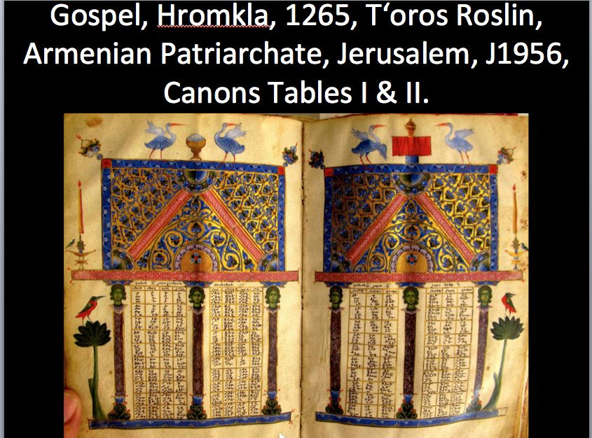instance the elaborate Canon Tables-Concordance-Index, serving as vehicles for some of the most intricate illuminations in manuscripts, totally disappears.
The first page of a Gospel manuscript began not with a title, but with a letter under arches 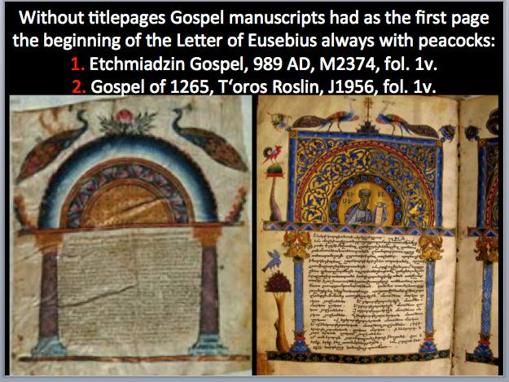 written by the inventor of the system, Bishop Eusebius of Palestine, to explain its use. Printed Gospels dropped the Letter along with the Canon Tables, almost from the beginning. The earliest separately printed full Gospel of 1680 by Michelangelo Barboni in Venice, had none, 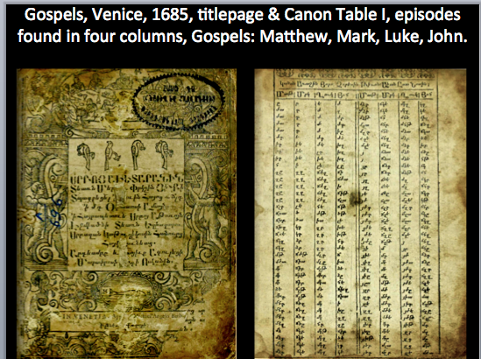 though curiously five years latter, Barboni another version, with the same engravings of the early edition, but this time adding the Eusebian Letter and Canon Tables. This seems to be the rare example of Canon Tables in a printed volume, probably because the printed version added elaborate indices.
The idea of the titlepage was so compelling that occasionally manuscript scribes copied them from printed books; 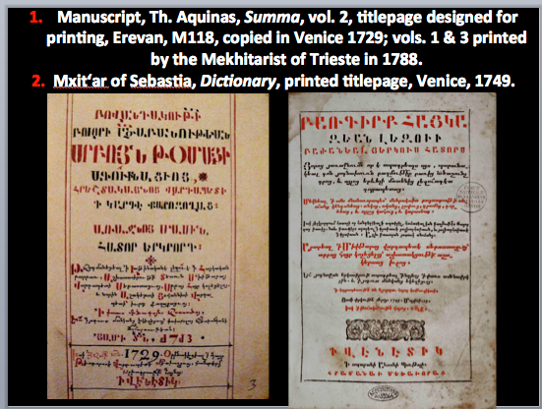 sometimes a monastic copyist even used as his exemplar a printed text rather than an earlier manuscript.
D. Content. The subject printed books changed little in the first three centuries from that of manuscripts. The majority of texts were religious, predominantly liturgical. There were some secular books right from the start among the volumes of Hakob Meghapart, and in the following century practical books for merchants and travels: ephemerides, almanacs, guides for weather forecasting, converting currencies, calculating distances, and much pseudo-science, especially astrology. After the mid-seventeenth century, there was an aggressive campaign to publish historical works, 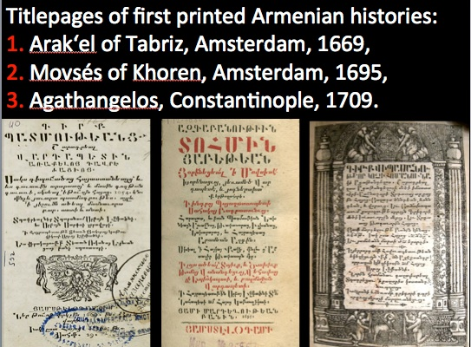 beginning in Amsterdam in 1669 with the contemporary History of Arak‘el of Tabriz, the first ever printed during the author’s lifetime, followed by Movses Khorenats‘i, Agathangelos, Zenop Glak, and others. Yet, we should not forget that in the centuries-old manuscript tradition, beside Gospels, Hymnals, Psalmbooks, Lectionaries, and the like, there were commentaries and translations of Greek, Syrian, and Latin church fathers, as well as the rich tradition of purely Armenian historiography and poetry. Little was to change in the print world until the nineteenth and twentieth centuries when the majority of books were on non-religious subjects. Yet, we should not forget that though Arak‘el's History was published, his contemporary Simeon of Poland’s remarkable travel account of trips to Armenian communities throughout the diaspora and Armenia, was not published until three centuries after his death.
IV. Illustrations in the Earliest Imprints.
The predominant source for printing texts was earlier Armenian manuscripts. Therefore, it is a surprise that this was not also true for their illustrations. There was apparently no mobility of monastic illuminators to the print trade, no recycling of the master artists of illustrated manuscripts. 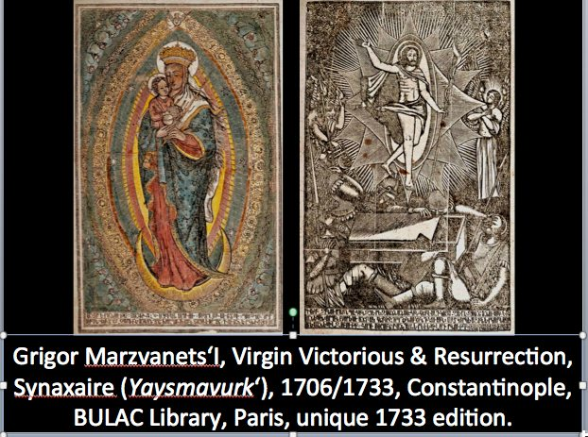 The exception is the Constantinople printer and engraver Grigor Marzvanec‘i, who was trained as a copyist and illuminator at the Amrdawla Monastery near Bitlis. His woodcuts are found in books that he and others published from 1706 to after 1734, when he died or simply retired. Though at first one can detect an influence from contemporary manuscript painting, Grigor developed a very characteristic graphic style, inspired 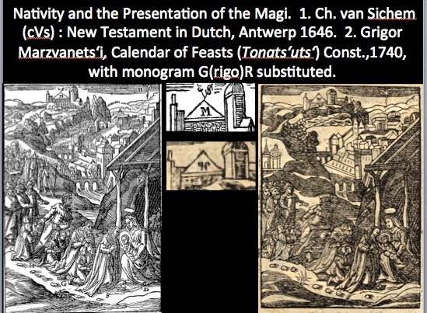 by both the iconography and manner of early European engravers. He often directly copied the work of Christoffel Van Sichem II, whose woodblocks were used in the popular Voskan Amsterdam Bible of 1666-1668 and the earlier Psalter and Hymnal.
Thus the style and iconography of early Armenian book illustration was entirely European, mostly Dutch. 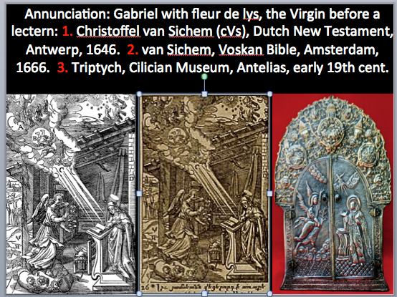 Some of this western art made its way through printing into still active Armenian scriptoria in certain Gospels but also other art. Seemingly a parallel, but independent, tradition in Armenian miniature painting flourished during these same centuries.
Miniaturists, especially in the second 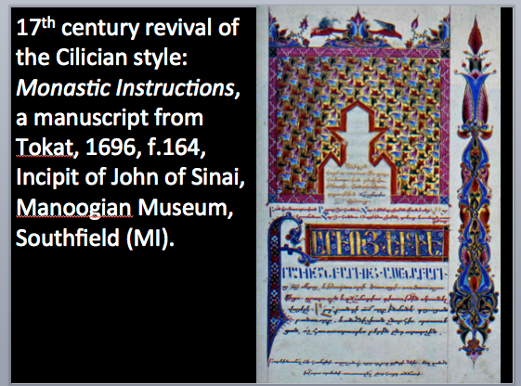 half of the seventeenth century, often turned to Armenian masters of the Cilician period rather than to the new religious iconography available through European engravings. Was this an intentional refusal to break with Armenian tradition, a rejection of the West, perhaps perceived as heterodox, as Catholic or Protestant?
Artistic borrowing and exchange are as old as art itself. 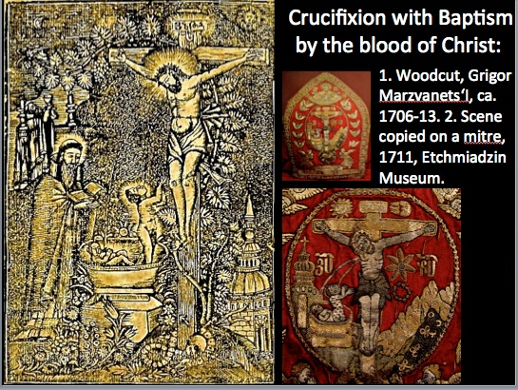 Grigor Marzvanec‘i's art was in turn freely copied by artists after him, for instance the unusual combining of the Crucifixion with Baptism by the blood of Christ on a mitre and the Nativity on a silver binding of 1798 from Constantinople with the Adoration of the Magi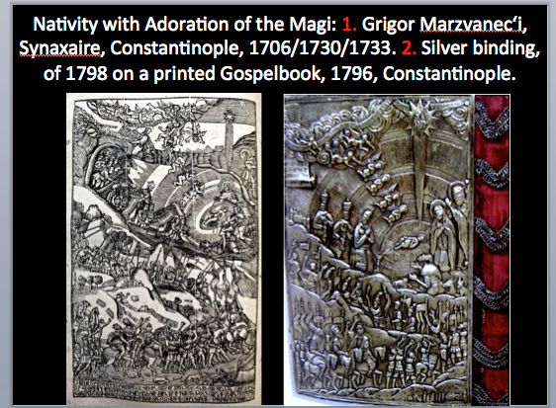 are copied from engravings of Grigor from his famous Synaxaire (Yaysmawurk‘) of 1706 and other works.
V. Conclusion
In the final analysis it is hard to say if these various interconnected evolutionary processes represent a revolution. In political terms, the French or American Revolutions for example, are almost instantly perceived as such, but in matters of cultural change, modification in modes of production, such as that of book-making, are only labeled "revolution" often long after the fact and usually in a figurative sense. Call it what you will. That there were radical modifications in how books were created and used is clear. Whether or not the concomitant changes in Armenian society, that is, all the innovations that make up what we call the modern or pre-modern period -- the role of the church, the introduction of secular ideas, the disruption in class structure -- were actually consequences of the adventure of printing is a question complicated enough to merit another conference.

