The Department of Earth and Environmental Sciences presents:

“The Great Pacific Garbage Patch: the science behind the hype”
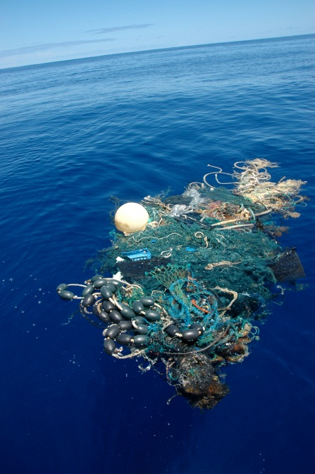
Abstract:
While plastic pollution is found throughout the world’s oceans, the North Pacific Subtropical Gyre, a remote area nestled between the trade winds and the westerlies, has been dubbed the “Great Pacific Garbage Patch.” Plastic pollution was first detected in this area in the early 1970s and has since become a matter of scientific and public concern. I will present data on the true nature of the “Garbage Patch,” including abundance, distribution, and size of plastic particles. I will also discuss how plastic particles interact with pelagic invertebrates, such as by being directly ingested, acting as a surface for oviposition, and transporting nonindigenous species. Though the large-scale ecological ramifications of open ocean plastic pollution remain unclear, the public is extremely concerned about this issue. I will therefore conclude with my experiences using social media to correct misconceptions and communicate science to broad audiences online.

Miriam Goldstein
Ph.D. Candidate, Integrative Oceanography Division
Scripps Institution of Oceanography, UCSD
Monday, October 1, 2012
East Engineering 191
3:00-4:00PM

