Financial Reports – CFS & Data Warehouse
July 11, 2011
On My Fresno State, click on Reports Portfolio > Financials. When you click on Financials, a small window should open up with a message of Logging-in to CFS. This box should go away within 8 seconds. If you chose to close the box before the 8 seconds, that is fine. Just let it log into CFS. You will see the Menu, just like what you see in the Fresno State Portal.

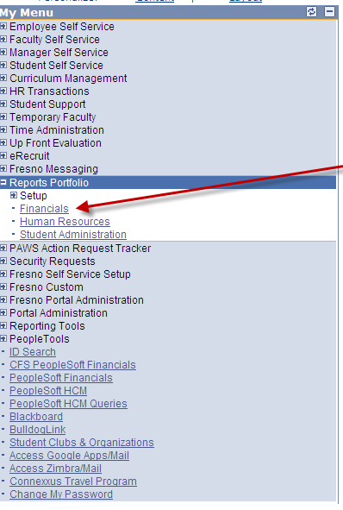

You will see the different categories. Some of these categories have new entries listed. If they labeled “CFS…”, these are going to CFS and will be accessing data in Fiscal 2011/12. If you are looking for data in Fiscal 2010/11 or older, then click on the other items. Some will say Prior Year and others will just have the label of what the link will provide. Some examples are below. (note: Some of the entries might not be listed on your screen. Please click on “Customize Report Selection” to see more entries. To add them to your listing, check the ones you want and click the “Save” link.)
- Accounts Payable
- Athletics General Ledger
- Financial Budgets
- Data Warehouse Reports
- Data Warehouse Query
- General Ledger
- nVision Reports
- Purchase Orders
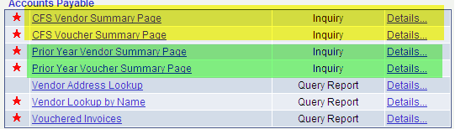
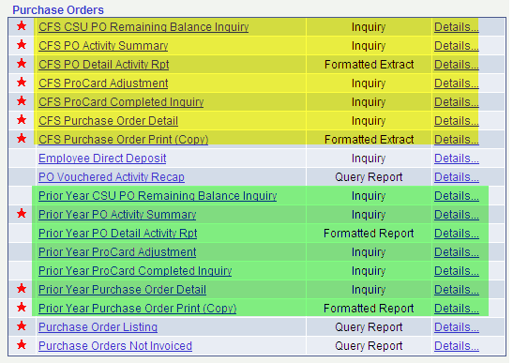

When running a report in CFS, like PO Print, please follow the steps below. Most of these are the same as you have done before. The screens look the same. You will need to add the Run Control. To add a Run Control, click the “Add a New Value” tab to enter the name of the Run Control you want to add.
- For Business Unit, enter FRSNO in both spaces. If you are printing a Purchase Order for FRATH, then you would enter FRATH.
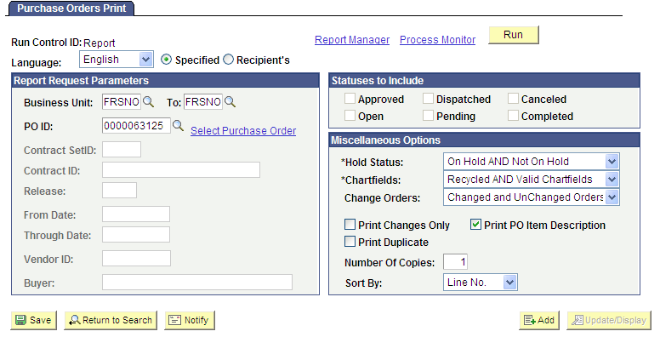

- Once you enter the Business Unit, PO ID and any other values, click the Run button.
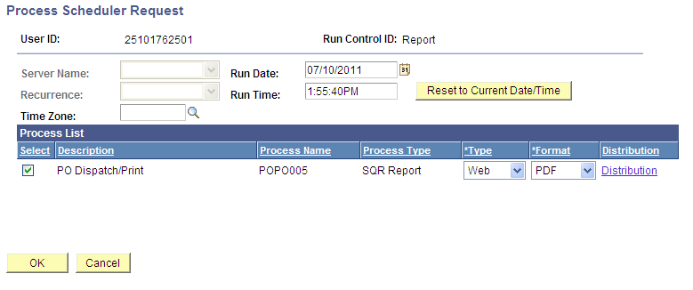

- Click the OK button to submit the request to start processing. It will take you back to Purchase Order Print screen
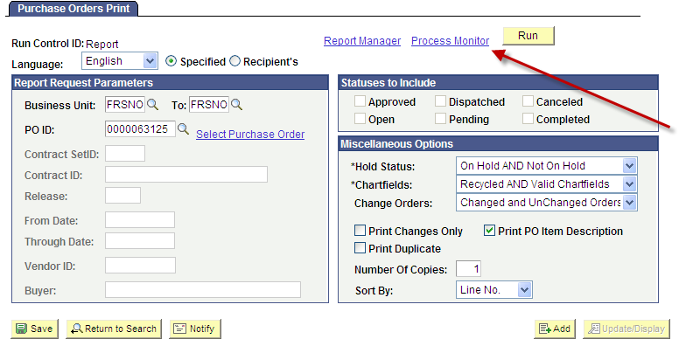

- To check the status of the job, click Process Monitor
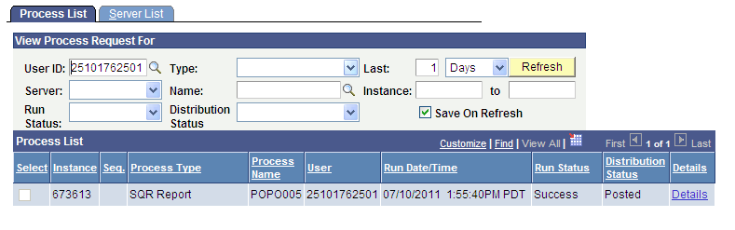
- Click on the Details hyperlink
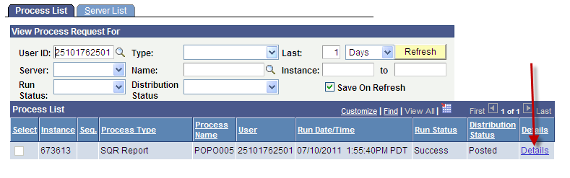

- Click on View Log/Trace to get to the Purchase Order you requested to print
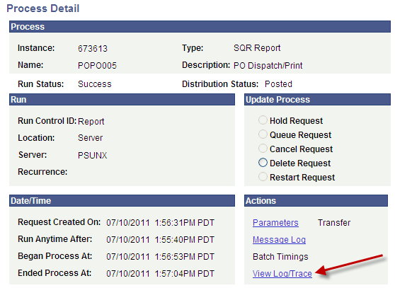
- After you click on View Log/Trace, the following screen appears. Under File List, you will see a pdf document that starts with “popo005…..”. Click on this document and you will see the printed copy of the purchase order. It will open up in Adobe Acrobat to print.
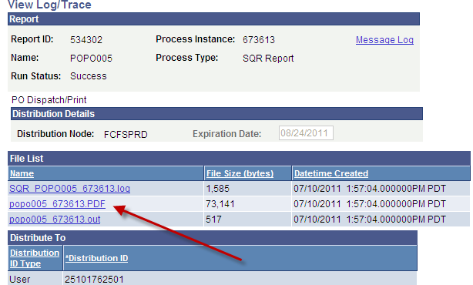

If you go to Reports Manager instead of Process Monitor, the system might log you off of PeopleSoft. If this happens, then you will need to close the screen and go back to Reports Portfolio in the My Fresno State portal.
For nVision Reports, they will only be available for a few months. These reports are only for prior years. The process to run an nVision report is the same as in the past. The only difference is where you can find the report output. Normally, the report would be listed under the “List” tab. Now, the reports are listed under the “Administration” tab.
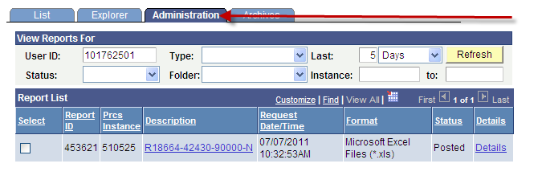

We have provided queries and reports in our Data Warehouse replacing several reports and all of the Reports Portfolio queries. There are still more reports to come. We are still working on Division, Trust Fund and reports with the roll-up functionality.
The data warehouse reports are not like the nVision reports. When the report runs, it is dynamic and will be on your screen. If you want to review it at a later time, you will need to save it as Excel, PDF or other option.
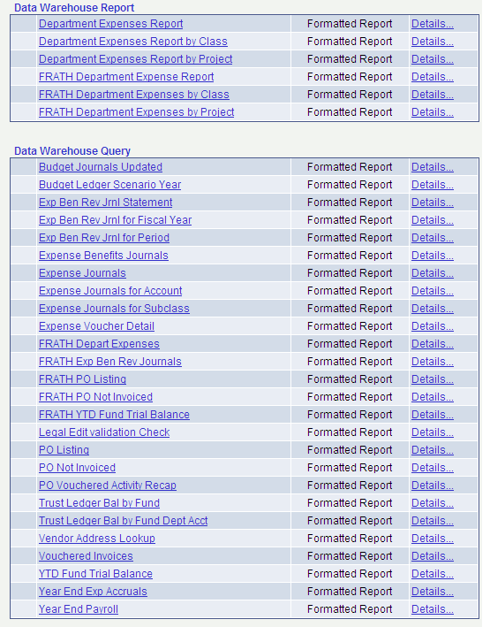

When you click on the Department Expense Report, the screen below comes up.
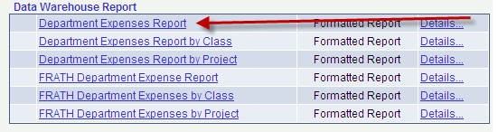
- You will enter the values for your request. After you fill-in the values, click the View Report button.

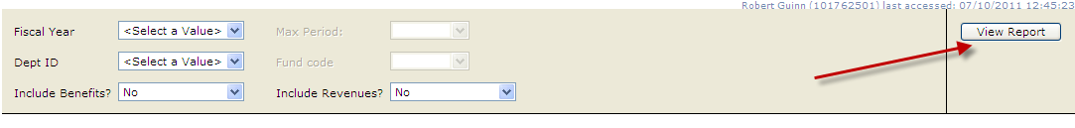

- The report will run and the output will be on your screen. The reports will display summarized and collapsed at specific levels. The queries will show the detail. To expand the different levels, click on the “+” to the left of the level description.
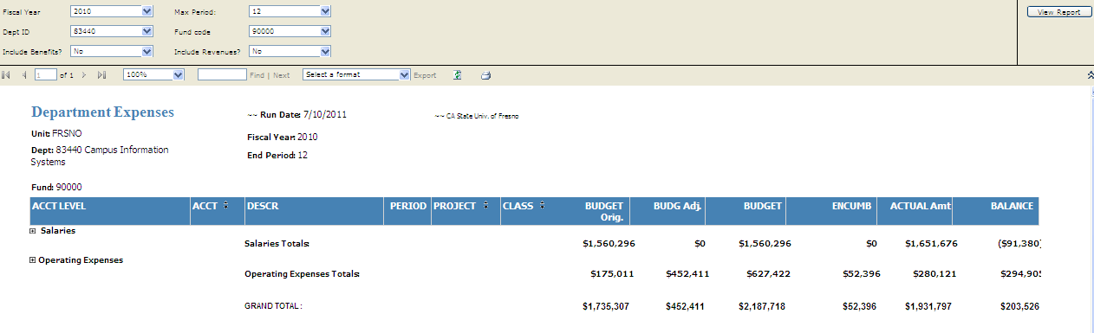

- To save/export the report, click on the drop-down arrow to the left of the Export label. There are 7 different options to save/export the report, ranging from Excel, CSV, Word and PDF.
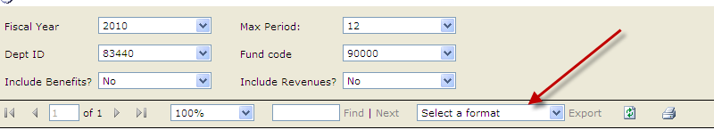
- Once you select the option, click the Export button. It will prompt you to either Open or Save the file in whatever format you chose. If you chose Save, you will have the opportunity to name the file and save it in a specific destination. If you chose Open, it will open on your screen. You can rename it and save it to a specific destination.

