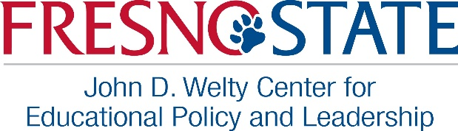
2019-2020 Middle Participation Form

District:
Mailing Address:
Superintendent’s Name:
Supt’s Phone: |  |  |  |  |  | Email:
Supt’s Admin Asst’s Name: |  |  |  |  |  |  |  | Phone:
Supt’s Admin Asst’s Email:

Our district will participate in Welty’s Executive Instructional Leadership Program for Rural Central Valley School Districts (“Rural Network”) for the 2019-2020 school year.
Fee to participate is a flat rate.
Our district will pay for the superintendent/district participation as follows (check one):
 | $1000 as a unified school district |  | $500 as a non-unified school district

Member Name | Email Address

Our district’s instructional leadership priority(ies) for 2019-2020 is (are):

Superintendent’s Signature |  | Date

Return to Mabel Franks. Scan and email to mafranks@mail.fresnostate.edu or FAX to 559.278.0175. Invoice will be sent upon receipt of completed form. Thank you! Looking forward to a great year.

