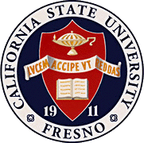
California
State
University,
Fresno
____

James Mullooly (Chair) - COSS
Ahmad Borazan - CSB
Dave Goorahoo - JCAST
Hovannes Kulhandjian - LCE
Kathi Rindahl - CHHS
Oscar Vega – CSM
Xuanning Fu - Ex-Officio
Elias Karam - ASI

Academic Policy & Planning Committee

Academic Senate
Henry Madden Library 3206
5200 North Barton Avenue M/S ML34
Fresno, CA 93740-8014

P 559.278.2743
F 559.278.5745

_{M E M O R A N D U M}

September 13, 2018

MEMORANDUM
TO: Thomas Holyoke, Chair
Academic Senate
FROM: James J. Mullooly, Chair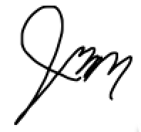
Academic Policy & Planning Committee

RE: APM 203 (Special Majors)

This memorandum will serve to inform the Academic Senate that the Academic Policy & Planning Committee moved to approve your consideration of the following modifications to APM 203 at our 8/30/18 meeting.
MSC: To delete the following sentence from APM203: “Units applied to satisfy General Education requirements may not be included in the Special Major.”

This is being proposed to accommodate EO 1110.

