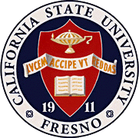
California
State
University,
Fresno
____

James Mullooly (Chair) - COSS
Ahmad Borazan - CSB
Florence Cassel Sharma - JCAST Xuanning Fu - Ex-Officio
Hovannes Kulhandjian - LCE
Tiewei Liu - HML
Primavera Martinez - ASI
Kathi Rindahl - CHHS
Oscar Vega - CSM

Academic Policy & Planning Committee

Academic Senate
Henry Madden Library 3206
5200 North Barton Avenue M/S ML34
Fresno, CA 93740-8014

P 559.278.2743
F 559.278.5745

_{M E M O R A N D U M}

February 15, 2018

MEMORANDUM
TO: Thomas Holyoke, Chair
Academic Senate
FROM: James J. Mullooly, Chair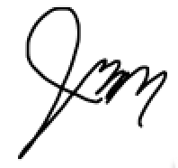
Academic Policy & Planning Committee

RE: APM405 (Student Records)

This memorandum will serve to inform the Academic Senate that the Academic Policy & Planning Committee moved to approve your consideration of the following modifications to APM 405 at our 10/19/17 meeting.
MSC: To forward draft for APM 405 to the Executive Committee for consideration based on the modifications Registrar Laura Yager has suggested.

The changes update executing orders and the names of campus offices. Additionally, EDC_67100 was deleted because it does not apply to this policy.

