THE MINUTES OF THE ACADEMIC SENATE (AS-12)
CALIFORNIA STATE UNIVERSITY, FRESNO
5200 N. Barton Ave ML 34
Fresno, California 93740-8014
Office of the Academic Senate
(559) 278-2743

April 10, 2023

Members excused: N. Akhavan, T. Lone, S. Moreman, P. Turnbull, W. Wise

Members absent: L. Brillante, B. DerMugrdechian, G. Newell, A. Panagopoulos, R. Perez, S. Peterson, N. Smith, B. Taylor

In-person attendance: 22 Zoom attendance: 31

The Academic Senate was called to order by Chair Hall at 4:03 p.m. in Library room 2206 and via Zoom video conferencing.

- Approval of the Agenda.
Senator Jenkins: Motion to move item #11 to item #7.
Motion seconded
Vote to modify the agenda: approved

Senator Dyer: Motion to approve agenda
Motion seconded
Vote on the amended agenda: approved

- Approval of the Minutes of 3/13/23.
Senator Pinzon-Perez: Emailed in a correction of what she said. Also requested to fix spelling of name.

Senator Stillmaker: Motion to approve the amended minutes
Motion seconded
Vote on the amended minutes: approved

- Communications and Announcements.

Communications from President Jimenez-Sandoval
Was on a panel on The Maddy Institute’s Summit on the Future of Ag
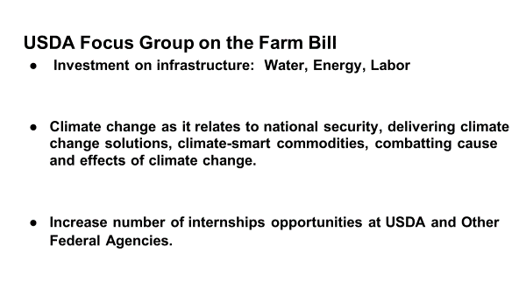
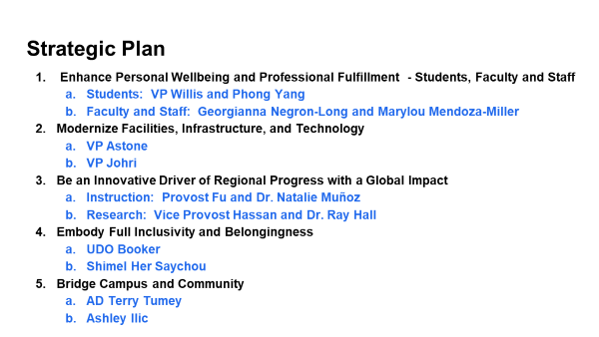
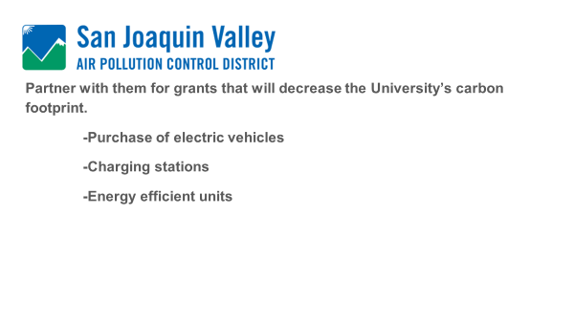
Town halls with updates from the Strategic Plan Steering Committees on May 3rd and 4th.
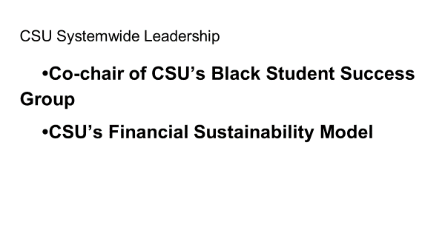
CSU Advocacy Day in Sacramento was a success.

The President’s Booth is up and running. People come by when the President is there. The Provost, ASI, and local leaders also have held hours there. Pie Day was a success.
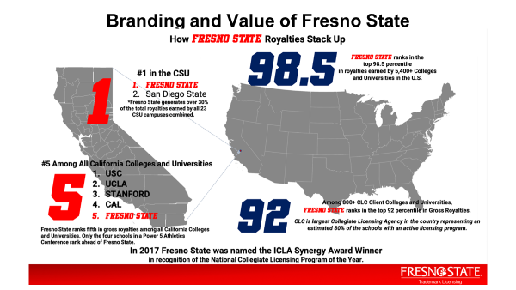

Senator Bryant: 30% from branding, where does it go?

President: There will be a full report later (before the last senate meeting) but royalties are not simple.

Senator Jenkins: What products are included when you mention branding?

President: Anything sold from the bookstore or online if it includes the logo especially. Wine is not included.

Senator Jenkins: Do you have an opinion about us offering doctorates and the community colleges offering bachelors.

President: The UCs have a constitutional mandate to offer PhDs. Community colleges have tons of money. How does the CSU fit in with this? We can advocate for a doctorate in public health but not all doctorates. Community colleges cannot offer Bachelor’s that are offered by CSUs – but they have so we have to figure out what that means and where we go.

Communications from Chair Hall
Chair Hall: 4/24 meeting and 5/1 meeting

Senator Jenkins: For the budget presentation, a year ago we requested a budget update from foundation/auxillary and the president promised to provide this so I am requesting to remind VP Astone to include the budget as it relates to foundation/auxillary on 5/1.

Chair Hall: The Academic Senate has many Ex-officio, non-voting members who can speak and Dr. Willis is our newest. We welcome him today.

Dr. Willis: I/My office is focused on recruitment, retention, and graduation. Recruitment includes recruiting underrepresented students and increasing readiness for college. Retention includes transformative co-curriculum outside the classroom. Graduation should include evidence driven-decisions so we are still working on this one. We want to take a proactive approach with students to keep them.

Senator Fobear: With your focus on marginalized population, does this include LGBTQ?

Dr. Willis: Yes, creating spaces where everyone belongs, and this includes LGBTQ students too. Plus we need to do more to support student organizations and parents – we have the most in the CSUs – so the campus needs to be more welcoming to families.

Senator Jenkins: Is there any work being done to address our partnership with community colleges to prepare students rather than us having to remediate them?

Dr. Willis: Yes, there is a meeting soon. We need to address students who finish at community college but don’t go on to us. At a recent visit to a local CC, their campus has ads but none of them are for Fresno State. We need to do better about not talking about it as a competition between systems and campuses.

Senator Huerta: Importance of friendly environment for parents, especially women of color, graduate student parent, first gen parents. We need to celebrate that and support them.

Dr. Willis: Agree, support first generation going on to graduate school, and also celebrate second and third generations.

Senator Schleivert: Update/follow-up: you may have seen an article headline that Fresno City College will be offering Baccalaureate degrees. This article is misleading. It discusses the 14 proposals submitted but not yet approved. There will be a statewide sentate meeting discussing this on Friday. 7 look like they meet the requirements – they meet a need and we don’t offer them. 7 others do appear to overlap with degrees/certifications in the CSUs. Please contact me if you have comments about this.

- New Business. – None

- Consent calendar
  - APM 200s – AP&P – Academic & Curricular Affairs: policies revised to align with new standard pronoun usage.
Chair Hall: These are corrections of pronouns and broken links.

- APM 322 – Policy on Assessment of Teaching Effectiveness.
Chair Hall: There were some senators who wrote in suggestions, so we will start with them.

Senator Kartch: II. D. 3. Add - The evaluated faculty member will not be held accountable for peer evaluations that were not submitted so long as they or their department chair provide evidence that reminders were sent and attempts were made to collect the missing peer evaluations.
Motion to add
Seconded
Carried

Senator Kartch: III. D. 1. f. Add – Suggested best practices for increasing response rates include: following the requirements described above in section III.C.1., III.C.4.a-b, and III.C.5.a-d. Other strategies include explaining that one welcomes and values feedback, explaining how student ratings have been useful in the past, sending email reminders, or offering a group incentive if the class achieves a target response rate.
Motion to add to III. D. 1. f.
Seconded

Senator Jenkins: The proposed amendment is not part of policy. I suggest making it a footnote.

Discussion on the floor re: addition to item f proposed by Senator Kartch. Senators Pitts, Randles, Lent, and Yang express concern with the ethics of trying to increase response rates and use of incentives.

Senator Miele: motion to strike incentive part of sentence.
Seen as friendly.

Senator Dyer: We may need to clarify this as a group. The idea is when there’s a low response rate, the results can’t be used. So maybe we need to differentiate between students who don’t want to with those who don’t try.

Senator Bryant: Question for clarification from Interim AVP Schmidtke, can this say it can be placed in the PAF?

Interim AVP Schmidtke: Yes. Other campuses are doing group incentives and getting good response rates. Having dedicated time in class also works.

Senator Pitts: Motion to strike item f in it’s entirety.

Parliamentarian Botwin: Out of order. Senator Pitts will need to make a motion after the current one is resolved.

Senator Jenkins: Call to question to resolve current discussion.
Seconded
Vote to call to question carries.

Vote on proposed addition to III. D. 1. f.
Motion does not carry, addition will not be included.

Senator Jenkins: Motion to strike III. D. 1. f. entirely: When response rates are below 50%, the faculty member must provide to the department chair a description of what efforts they took to solicit feedback from students. They may be required (by the Personnel Committee) to provide additional peer evaluations or self-reflections to make up for student ratings that are unusable due to a low response rate.
Seconded

Senator Dyer: As a member of the committee who recommended this, there is a reason it is in there because committee members reviewing RTP files will, in the absence of guidance telling them not to, use data from low response rates. Additionally the 50% baseline is based on statistical reliability and is based on classes of approximately 20 students. The average class size on campus is 24. So the results of student evaluations could be defended scientifically in court if that baseline is met.

AVP Jim Schmidtke: The 50% is not part of CBA, they go into the PAF regardless. One department that I know of on campus does require at least 50%, so if the senate does remove this that decision can still be made at the department level.

Discussion on the floor regarding motion to strike III. D. 1. f.: Senator Archambault expressed concern that removing item f allows a professor to explain why there were low response rates, so they are not punished if they have low rates. Senator Wakabayashi expressed concern that the burden is on the faculty. Senators Lent, Yang, and Pitts expressed support to strike f. Senator Pinzon-Perez expressed support for the baseline of 50% but thinks the wording could clarify if it is 50% of the mean or median.

Senator Jenkins: motion to extend time 10 minutes.
Seconded.
Vote carries.

Motion to strike item III. D. 1. f. vote carries.

The Academic Senate adjourned at 5:20p.m.

----------------------------------------------------------------------------------------------
The next meeting of the Academic Senate will be on April 24, 2023.

Submitted by Approved by
Andrea Roach Ray Hall
Vice Chair Chair
Academic Senate Academic Senate

