Re: Memo to Executive Committee of the Academic Senate Re: NEW Priority and Early Registration Policy (400s)

Laura Yager | 12:44 PM (2 hours ago)
Hi Dr. Hall,

Based on the feedback I received at the Executive Committee meeting last Monday 3/27, please find the attached updated APM for Priority and Early Registration Policy. I made the following minor edits:
- Made sure the use of new committee name SEMC was used throughout the policy (replaced old EM acronym)
- Changed title of OIE Director to AVP
- Updated the table to hopefully provide more clarity to the registration order
Also, here are the updated numbers for you to share with the committee:
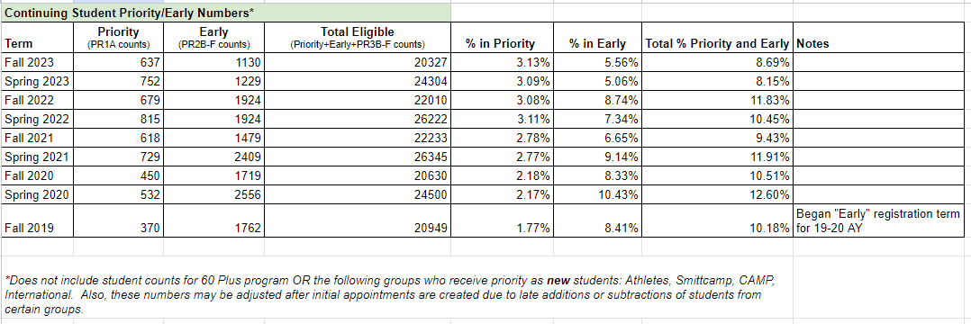

Thank you for providing feedback and working with me on getting this new policy approved. I wanted to summarize my understanding of what was discussed on 3/27 regarding moving forward with this policy:
- With only a couple meetings left this semester, it will not be approved prior to fall 2023.
- Since the changes that were suggested were only minor, the next step is this will go to the Academic Senate for a first reading.
- It should be at a 'top' priority to get approved in the first few senate meetings of the fall 2023 semester.
- Phong Yang, current Interim AVP Enrollment Management, could request a call for faculty representation on the current Strategic Enrollment Management Committee now for the fall 2023 semester.
- The executive senate did not have any major concerns with the policy and were overall in support.
- Given the committee is already formed and meeting regularly and priority/early registration is already operating under their purview, we can move forward with the proposed changes now since they are more operational. These changes do not need to necessarily wait for Academic Senate approval of this new APM.
Is my last comment correct? I wasn't quite sure if I interpreted that accurately or not. If you could provide clarification on that, I would appreciate it.

Again, thank you for your help and support with this!

Laura Yager, M.A. (she/her/hers)
University Registrar
Director of Veterans Services

Division of Student Affairs and Enrollment Management
California State University, Fresno
p: 559.278.6114 | fax: 559.278.6020 | lyager@csufresno.edu
http://fresnostate.edu/registrar
http://fresnostate.edu/veterans

