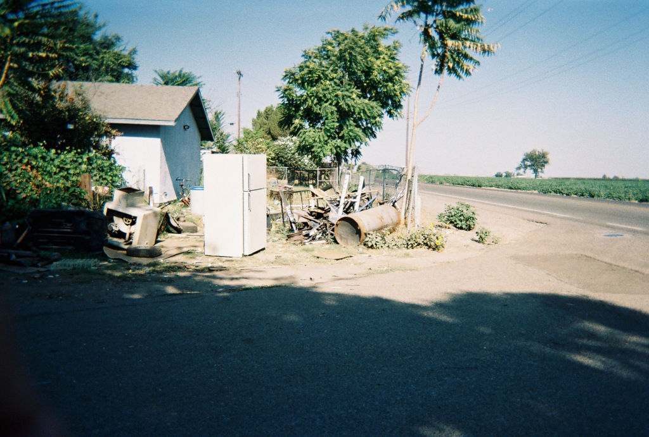

Home Garden
Community Assessment Report

Alicia Gonzalez, Marlene Bengiamin, John Capitman
Central Valley Health Policy Institute
California State University, Fresno

March 2007

Home Garden
Community Assessment

Alicia Gonzalez
Marlene Bengiamin, Ph.D.
John Capitman, Ph.D.

Prepared by:

Central Valley Health Policy Institute
Central California Center for Health and Human Services
College of Health and Human Services
California State University, Fresno

This publication was funded in part by a grant from



Table of Contents

Table of Contents 1

List of Tables and Attachments 2

Executive Summary 3

Introduction 5

Objectives 6

Methods 6

Data Collection/Analysis 7

Photovoice Project 7

Needs Assessment Results 10

Conclusion 27

Next Steps 28

References 29

List of Tables & Attachments
TABLES

Table 1: Family Survey and Elder Survey Topic Areas 6

Table 2: Demographic Characteristics of Family Respondents, 2006 10

Table 3: Demographic Characteristics of Elder Respondents, 2006 11

Table 4: Usual Source of Health Care among Home Garden Families, 2006 12

Table 5: Usual Source of Health Care for Elders, 2006 12

Table 6: Family Emergency Room Visits for Chronic Conditions
in the Past 12 months, 2006 13

Table 7: Elder Emergency Room Visits for Chronic Conditions
in the Past 12 months, 2006 14

Table 8: Family Barriers in Receiving Needed Health and Social Services, 2006 15

Table 9: Elder Barriers in Receiving Needed Health and Social Services, 2006 15

Table 10: Family Chronic Condition, Rate of Satisfaction
of Medical Care and Help Needed, 2006 17

Table 11: Elder Chronic Condition, Rate of Satisfaction
of Medical Care and Help Needed, 2006 18

Table 12: Family and Elder Respondents with More than One Chronic Condition 20

Table 13: Activity Level among Elders, 2006 20

Table 14: Elder Assistance around the House, 2006 21

Table 15: Elder Satisfaction rate with Home Health Services 22

Table 16: Family and Elder Common Problems and Needs in Home Garden, 2006 23

ATTACHMENTS

Attachment A: Family Community Assessment Survey 30

Attachment B: Elder Community Assessment Survey 37

Attachment C: Event Agenda 46

Executive Summary

Home Garden is an unincorporated community within Kings County, situated adjacent to the City of Hanford. Home Garden faces important challenges in health care access and social services for elders, families and children. Hand In Hand Family Resource Center (FRC) initiated this community assessment in an effort to identify problems in the community. Hand in Hand FRC serves the community of Home Garden under the guidance of Kings Partnership for Children (KPC), its corporate and fiscal entity. The Hand In Hand FRC is partially funded by The California Endowment, United Way of California and First 5 of Kings County. Their mission is to advocate for children and families to improve the quality of their lives.

This community assessment identifies the healthcare, social service needs, and access issues experienced by members of this underserved, rural community in California's Central Valley. In order to provide a context for this assessment, we begin with an overview of the community. Home Garden is a small community of a little over 1,700 residents. In the last decade this community has seen a shift in demographics from a predominantly African American to a mostly Latino population, with very limited or no access to health and social service facilities.

Objectives: The objectives of this community assessment project were to increase knowledge of the KPC Board, staff and community regarding health, social service and access issues through the collection and analysis of local data. We also sought to identify and prioritize physical and mental health needs through a grass roots community engagement process and to create community driven strategies that empower local residents to take action.

Methods: The data collection involved face-to-face survey interviews with 183 parents of school-aged children and 53 elders currently living in Home Garden. Survey topics included: their overall views about common problems in Home Garden; barriers to receiving needed health and social services; usual sources of care for residents; insurance status; self and family’s chronic health conditions, family demographics including age, gender and race/ethnicity; and qualitative questions on health and community support service needs. Elders were asked additional questions about their activity level, assistance with activities of daily living and satisfaction with support services. Tables were constructed and used to record the identified issues of both families and elders. Data collection also included a youth Photovoice project which involved ten youths who were trained and supervised to photograph the areas in their communities they perceived as strengths and concerns.

Findings: The family and elder interviews revealed a need for access to health care and social services, affordable insurance, recreation, and enhanced community service. The community envisioned a future that is safe and healthy and that provides accessible health and social services. The Photovoice project enabled youth to express concerns about environmental burdens in their neighborhood. The use of Photovoice empowered these young people and served as a powerful tool for the community's voice. This community assessment was enhanced by the use of Photovoice by combining the community's story through the eyes of the youth.

Recommended Next Steps: Based on the findings from the community assessment, the following are recommendations for next steps for the Hand In Hand Family Resource Center:

(1) Disseminate the community assessment findings to the Home Garden community.
(2) Disseminate findings to larger political stakeholders in Kings County.
(3) Create opportunities for community discussion and seek to develop an action agenda to take to Hanford and Kings County decision makers.
(4) Celebrate the new clinic and work with clinic sponsors to address access barriers.
(5) Work with clinic sponsors on specifically addressing chronic disease management and eldercare issues.

Introduction

The Hand In Hand Family Resource Center (FRC) serves the community of Home Garden under the guidance of the Kings Partnership for Children (KPC). The Hand In Hand FRC is partially funded by The California Endowment, United Way of California and First 5 of Kings County. The mission of the Hand In Hand FRC is to advocate for children and families to improve the quality of their lives. The center provides resources to the community such as parenting classes, clothes drives, community baby showers, and legal referral service assistance. Thanks to a two-year grant from The California Endowment, the Hand In Hand FRC expanded its service abilities enabling them to conduct a community assessment in Home Garden. The goal of the project was to gain knowledge about access to health and social services by residents of this community.

The Hand In Hand FRC developed a sub-contract relationship with the Central Valley Health Policy Institute (CVHPI) in order to develop the community health survey instrument and to analyze the data collected to determine the top health and social service access issues impacting Home Garden residents. The scope of work also included facilitation of the youth Photovoice project. Family and elder survey questions including: overall views and common problems of Home Garden; perceived barriers to receiving health and social services; usual sources of care; insurance status; self and family’s chronic health conditions, demographic information including age, gender and race/ethnicity of family members; and qualitative questions on health and community support service needs. Elders were asked additional questions about their activity level, assistance with activities of daily living and satisfaction with support services.

Home Garden is an unincorporated community within Kings County, situated adjacent to the City of Hanford. The total population of Home Garden was 1,702 in 2000 (U.S. Census Bureau, 2000). Home Garden’s racial/ethnic composition shifted dramatically in recent years from a predominantly African American community to a mostly Latino community. According to the Hand In Hand FRC, the current population of Home Garden is 49% Hispanic, 23% Caucasian, 17% African American, 7% Hmong, and 4% other. Almost 20% of the residents are foreign-born. The predominant languages are English, Spanish and Hmong. The median income is $14,535 per family, which reflects the dire poverty faced by many residents (KPC, 2006).

In an effort to gain knowledge about how ethnic demographics have changed in recent years, the community assessment survey included questions about race and ethnicity. The ethnic demographic information gathered from the survey will help in understanding the needs of the community and assist in learning whether services should be culturally tailored to best meet the diverse needs of Home Garden residents.

Objectives

The goal of this community assessment was to learn more about the physical and mental health service needs and access issues experienced by members of this community, as well as to learn more about the concerns and issues faced by community members. The project was designed to input to the strategic planning process that Hand In Hand FRC and KPC are conducting with the Home Garden community, as detailed in KPC Communities First Proposal to The California Endowment. Specifically, the objectives were to:

- Increase the knowledge of the KPC Board, staff and community of the health needs and access issues, through the collection and analysis of local data.
- Identify and prioritize physical and mental health needs through a grass roots community engagement process.
- Create community driven strategies that empower local residents to take action.

CVHPI and Hand In Hand FRC conducted several focus groups with community leaders and others to further refine the goals of the project and to identify the best approaches for collecting needed information. Based on these meetings, the project sought to examine life in Home Garden from the perspectives of young people, families, and elders. Three distinct study components were implemented to record and present the experiences of all three groups: 1) a survey of families, 2) a survey of elders, and 3) a Photovoice project with youth. All assessment instruments, tools and data collection sources were developed and implemented with the community members from the Hand In Hand FRC. In the following sections we will discuss the project methodology, findings, and some potential next steps for Home Garden.

Methods

This report used primary data obtained from the Home Garden community assessment surveys. The survey instrument was developed by the Central Valley Health Policy Institute, with the guidance of the Hand In Hand FRC directors, project steering committee, and community leaders. The set of topics were selected by this same group of advisors with further input from the FRC. The family and elder surveys addressed similar topics (Figure 1). The elder survey topics included activities of daily living, personal care and home maintenance activities, activity level, and satisfaction with social support services. These topics were derived from standardized questions used in other elder health assessment studies. In addition, the elder survey included three additional topics relevant to the health and community tenure of older adults. (Refer to Attachment A for the Family Survey and Attachment B for the Elder Survey.)

Table 1: Family Survey and Elder Survey Topic Areas

Family Survey |  | Elder Survey
1 | Overall views of Home Garden | 1 | Overall views of Home Garden
2 | Common problems in Home Garden | 2 | Common problems in Home Garden
3 | Barriers to receiving needed health and social services | 3 | Barriers to receiving needed health and social services
4 | Usual source of health care and insurance status | 4 | Usual source of healthcare and insurance status
5 | Disease prevalence in family | 5 | Disease prevalence in family
6 | Emergency room utilization in the past 12 months | 6 | Emergency room utilization in the past 12 months
7 | Family’s age, gender, race/ethnicity | 7 | Family’s age, gender, race/ethnicity
8 | Qualitative questions on health and community  support service needs | 8 | Qualitative questions on health and community support service needs
 |  | 9 | Activity level among elders
 |  | 10 | Assistance with activities of daily living
 |  | 11 | Satisfaction with support services

Data Collection
The face-to-face interviews with families and elders currently living in Home Garden were conducted by six Home Garden community health advocates. A detailed training on data collection and protection of the confidentiality of human subjects was conducted with staff in preparation for survey implementation. A total of 183 family and 53 elder interviews were completed from August through October 2006. A total of 187 survey interviews were conducted in English; 36 were completed in Spanish; and 13 in Hmong. The data entry, analysis, and final report were prepared by the staff at the Central Valley Health Policy Institute.

Analysis

Quantitative analysis was conducted using SPSS 11.0 for MS Windows. The frequency of responses to questions addressing common problems in Home Garden, health and social service access issues and health care coverage were analyzed using weighted average scores to provide a common measure of the relative importance of each concern by residents. We analyzed emergency room utilization, family’s age/gender and race/ethnicity. Questions addressing chronic condition prevalence, rate of satisfaction with medical care received, and whether or not families and elders need help in managing their condition were analyzed.

Qualitative analysis was conducted using all verbatim typed answers to the open ended questions. Analysis was performed using an inductive approach, combining biomedical and sociological perspectives. This balanced approach was felt to be the best approach, considering the main objective of the study was to contribute to a better understanding of the community’s views and perspectives on the health and community support service needs. The authors started the analysis with open inductive coding, through an intense line-by-line reading of individual surveys. Data collection and analysis continued simultaneously. Finer coding was applied as more data were coded and analyzed. Throughout the analysis, we wrote memos to store ideas, insights, and interpretations. This was essential in the development of analytical ideas. The provisional coding scheme generated was discussed with other members of the research team, after independent reading of a sample of surveys. Some codes were refined, and researchers moved to axial coding, looking for categories and themes, and then to selective coding.

The Photovoice Project

Photovoice is a participatory-action research methodology developed by Caroline C. Wang, DrPH, MPH at the School of Public Health, University of Michigan, in 1992. Photovoice is based on the understanding that people are experts on their own lives. It is designed to empower the marginalized or disenfranchised members of any given community. Photovoice aims to achieve three main goals: empowerment of the participants; a needs assessment of the community from a previously unknown perspective; and action occurring around the assessed needs. Activities around these goals involve: enabling people to record and reflect their community’s strengths and problems through photography; promote dialogue about important issues through discussion around the photographs; and to reach and inform policymakers on an emotional level in an effort to change or implement policy (Health Education & Behavior, 2001).

Photovoice Methodology: The Photovoice component involved a group of 10 Home Garden youth (ages 10-17) who photographed images and situations in Home Garden that they felt were either a community strength or concern. Forty-eight photographs were selected and the youth photographers wrote about them using the Photovoice SHOWeD method also developed by Wang (2001). This method asks specific questions relevant to the photos such as: What do you See here? What is really Happening? How does this relate to Our lives? Why does this problem or strength exist? What can we Do about it? Please visit www.cvhpi.org or www.kingspartnership.org to view the Power Point slide presentation with the 48 photos taken by the youth photographers and viewed by the youth as the most important photos to be shared with the community.

Youth Photographer Training: During the development of the Photovoice project, three training meetings were held at the Hand In Hand FRC to discuss the goals of the project, ethics in photography, photography tips, and the importance of obtaining consent release forms from the youth. Although the youth participants and FRC staff both identified illegal drug sales by some residents as a significant influence on community life in Home Garden, the safety of project participants was a major consideration. During the training meetings, the youth participants, the director of the Hand In Hand FRC and the Photovoice project facilitator discussed this issue and emphasized to the youth that photographing drug related situations was prohibited due to the dangerous nature of the photographs, which may have placed the youth in a harmful situation. The following consent forms were reviewed with the youth:

1. Participant Release Form: Consent obtained by the project staff from the youth photographers outlining their rights and responsibilities as participants of the Photovoice project.

2. Minor Photograph Acknowledgment and Release Form: Consent obtained by the project staff. Before taking a photograph of a child, the parent or guardian of the minor child signs an acknowledgment release form.

3. Adult Photograph Acknowledgement and Release Form. Consent obtained by the project staff from the youth photographer. Before taking a photograph of an adult, the youth photographer receives a consent signature from the adult participant.

4. Photograph Permission Release Form: Consent obtained after all of the youth’s photographs have been developed and discussed, indicates that the youth photographer gives permission for the pictures to be published or used to promote the project's goals and other informational purposes.

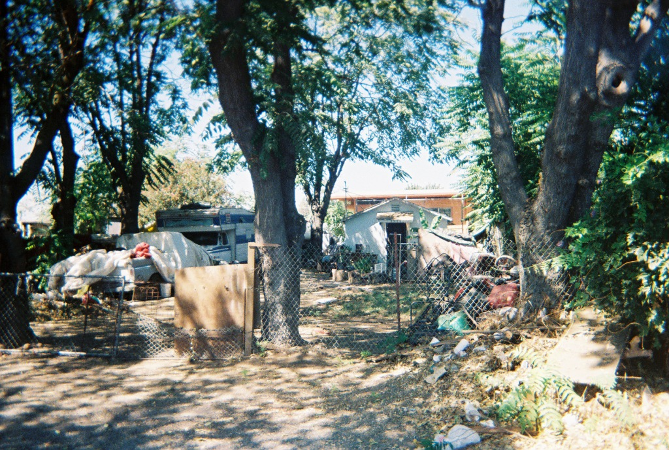
Photovoice Results
The youth of Home Garden have served as the powerful voice behind the camera, capturing and reflecting Home Garden’s strengths, concerns, and needs through photography. Photovoice enhanced what the needs assessment captured by combining the community’s story through the eyes of the youth. Photovoice enabled the ten youth photographers to express concerns about the environmental burdens in their community. They felt the unclean appearance of the community gives a bad impression to the public. The youth pictures and their written interpretations highlight a poorly maintained and dangerous community that has been destroyed by the impacts of resident poverty. Poor road maintenance and the disorderliness of the residents who pile junk in their front yards were often photographed. Graffiti in the neighborhood is very common. Youth photographed a stop sign with graffiti, truck trailers with graffiti, and even a photo of a street with graffiti.
“A pile of junk, a couple of cars, a fence that needs to be re-done. The people do not clean up their yard and should get the cars running and pick up the pile of junk. It makes our neighborhood look bad. Because people do not clean-up their yards.

Youth photographer, Age 14

Since there is no community park in Home Garden, kids are forced to play in the streets. Three youth photographed the image of a teenager jumping the fence of the Gardenside Elementary School which is locked to prevent youth from playing on school grounds after school hours. The issue of not having sidewalks in Home Garden, except near the elementary school, is important to the youth because they feel it will increase the risk of a child being hit by a car.
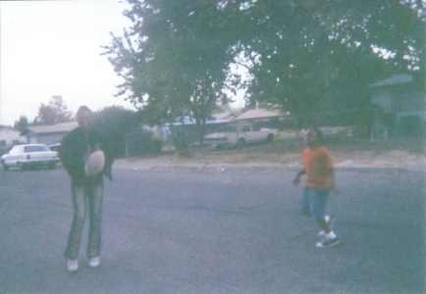
“Kids not having no where to play at so they are playing in the streets. Kids playing in the streets and one day they might get run over by a car or a bus. One day our brother, sister or other relative might be injured. The problem exists because kids have not where to go after school. We can do a lot of things like build some where to play.

Youth Photographer, Age 14

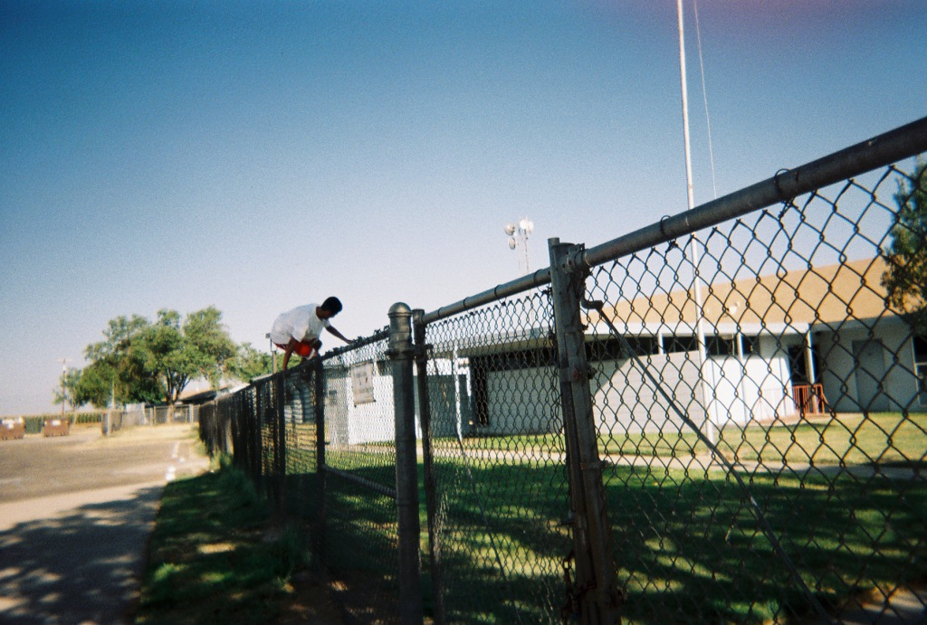
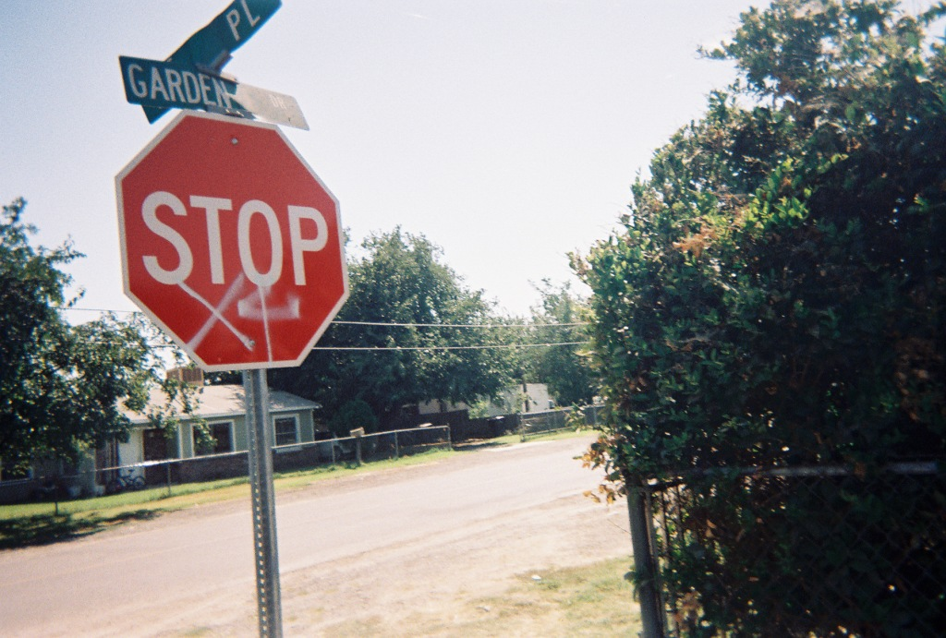

“A gang sign on a stop sign.

Kids being bored, then they turn to gangs.

It should not be there.

Because some kids that do this don’t have nothing else to do.

Have more programs to get kids out of the gang stuff.”

Youth Photographer, Age 16
“I see a kid.

The kid is trying to jump the fence to play at the school.

It makes it harder for us to have fun.

Because they lock the school gates.

We can unlock the gate and get free access into the school.”

Youth Photographer, Age 17

Needs Assessment Results

Family Demographics: The community’s residents are primarily Latino/Hispanic. Of the 183 family respondents, 62% were Latino/Hispanic; 15% were African-American; 15% were White; 6% were Hmong/Southeast Asian. The “Other” category included Arabic, Japanese, Native American Indian, Pacific Islander, and American Indian (Table 2). If respondents belonged to more than one racial/ethnic group, and one of them was not listed on the survey, they wrote the second racial/ethnic group next to ‘Other’ category. The survey sample race/ethnicity demographics are comparable to the Hand In Hand Family Resource Center’s community race/ethnicity figures listed in the introduction. In this report we aggregated age to six categories. Majority of the respondents (29%) were between 36 and 45 years of age. More than half (58%) of the family respondents were female; 32% were male; and 10% did not provide their gender. Seventy percent of the respondents had lived in Home Garden for more than five years; 20% had lived there between one and four years and 10% had lived there less than one year.

Table 2: Demographic Characteristics of Family Respondents, 2006

Demographic Characteristics of Family Respondents | Frequency  # | Percent  %
RACE/ETHNICITY
Latino/Hispanic | 114 | 62%
Hmong/Southeast Asian | 11 | 6%
African-American | 27 | 15%
White | 27 | 15%
Other | 2 | 1%
Missing Values | 2 | 1%
TOTAL | 183 | 100%
AGE BRACKETS
15-25 | 26 | 14%
26-35 | 37 | 20%
36-45 | 53 | 29%
46-55 | 33 | 18%
56-65 | 19 | 11%
66-75 | 7 | 4%
Missing Values | 8 | 4%
TOTAL | 183 | 100%
GENDER
Male | 59 | 32%
Female | 106 | 58%
Missing Values | 18 | 10%
TOTAL | 183 | 100%
YEARS LIVING IN HOME GARDEN
Less than 1-yr | 18 | 10%
1-4 yrs | 37 | 20%
5 yrs or more | 128 | 70%
TOTAL | 183 | 100%
Source: Family Survey Data, 2006

Elder Demographics
Similar to the family survey findings, the largest group of respondents was Latino/Hispanic (42%). African-Americans accounted for 24% of the elder respondents; whites were 15%; Hmong/Southeast Asian were 11% and those who reported “other” ethnicity comprised 7%. The “other” category included Portuguese and American-Indian. As with the family survey, age information was aggregated into five categories. Respondents between 51 and 60 represented 34% of the respondents. We found similar rates of female and male respondents among the elders, 53% and 43% respectively (Table 3). Close to eighty percent, (78%) of the elder respondents have lived in Home Garden for five years or more. Nearly ten percent (9%) have lived there between one and four years and 13% have lived there for less than one year.

Table 3: Demographic Characteristics of Elder Respondents, 2006

Demographic Characteristics of Elder Respondents | Frequency # | Percent %
RACE/ETHNICITY
Latino/Hispanic | 22 | 42%
Hmong/Southeast Asian | 6 | 11%
African-American | 13 | 24%
White | 8 | 15%
Other | 4 | 8%
TOTAL | 53 | 100%
AGE BRACKETS
40-50 | 5 | 10%
51-60 | 18 | 34%
61-70 | 15 | 28%
71-80 | 12 | 23%
81-90 | 3 | 5%
TOTAL | 53 | 100%
GENDER
Male | 23 | 43%
Female | 28 | 53%
Missing Values | 2 | 4%
TOTAL | 53 | 100%
YEARS LIVING IN HOME GARDEN
Less than 1-yr | 7 | 13%
1-4 yrs | 5 | 9%
5 yrs or more | 41 | 78%
TOTAL | 53 | 100%
Source: Elder Survey Data, 2006

Family Sources of Medical Care
Family respondents were asked two separate health care access questions. The first question asked: Do you have a place you usually go to when you are sick or need medical advice? The majority of the respondent families (80%) reported having a usual source of medical care when they were sick or needed medical advice; whereas 19% did not have a usual source of medical care. Over thirty percent (34%) of the families who reported not having a usual source of medical care, said the main reason was not having or having lost insurance.

The second question was: What is your usual source of health care? Table 4 indicates the most common sources of medical care. Approximately forty percent (40%) of the families reported going to a clinic/community health center; 32% visited doctor’s private medical offices. Eighteen percent (18%) of the respondents reported using the hospital emergency room as their usual source of medical care. It is apparent that those who lacked a usual source of care (19%) resorted to using a hospital emergency room when they were sick or need medical advice. This is higher than the national trend of 16.2% (Kaiser Family Foundation, 2004).

Table 4: Usual Source of Health Care among Home Garden Families, 2006

FAMILIES - USUAL SOURCE OF CARE | Number | Percent
Doctor's office | 58 | 32%
Hospital ER | 32 | 18%
Clinic/Community Health Center | 74 | 40%
Don't have a usual source of health care | 15 | 8%
Missing values | 4 | 2%
n= | 183 | 100%
Source: Family Survey Data, 2006

Elder Sources of Medical Care
Elder respondents were also asked about healthcare access. The majority of the elders (83%) reported having a usual source of medical care when they were sick or needed medical advice and 17% reported that they did not have a usual source of medical care. Table 5 describes the main sources of medical care among elders. Over forty-seven percent (47%) used a private doctor’s office as their usual source of care and 34% reported using a clinic or community health center for their usual source of care. About six percent (6%) reported using the hospital emergency room as their source of medical care.

Table 5: Usual Source of Health Care for Elders, 2006

ELDERS - USUAL SOURCE OF CARE | Number | Percent
Doctor’s office | 25 | 47%
Hospital ER | 3 | 6%
Clinic/Community Health Center | 18 | 34%
Don’t have a usual source of health care | 7 | 13%
n= | 53 | 100%
Source: Elder Survey Data, 2006

Family Emergency Room Visits
Respondents were asked if they, or a family member, had gone to the emergency room in the past twelve months for any of the following conditions: arthritis, diabetes, heart disease, farm accident, asthma, high blood pressure, two or more of the listed conditions, car accident, or other condition. A surprisingly high percentage of the respondents (62%) reported that someone in their family made an emergency room visit in the last year. Only one percent (1%) went to the ER for a farm labor related accident; 3% for car accident; and 17% visited the ER for other conditions. In contrast, over 50% of the ER visits were associated with chronic conditions that would normally be managed with primary care visits (Table 6). The following quotes are directly from the qualitative data in the family surveys:

“I make too much for Medi-Cal, so I use hospital emergency instead of doctor/clinic”
“I use hospital emergency because I have no insurance”
“I go to emergency room, don't know where else to go”
“The emergency room, only place to go”
“I returned my insurance, cost me $475 a month, I can’t afford it”

Table 6: Family Emergency Room Visits for Chronic Conditions in the
Past 12 months, 2006

FAMILY e.R. visits for chronic conditions | Number | Percent
Arthritis | 9 | 5%
Diabetes | 9 | 5%
Heart Disease | 3 | 2%
Farm Accident | 2 | 1%
Asthma | 19 | 10%
High Blood Pressure | 16 | 9%
2 or More of Above Conditions | 20 | 11%
Car Accident | 5 | 3%
Other Condition | 31 | 17%
Total # of ER visits | 114 | 62%
Source: Family Survey Data, 2006

Elder Emergency Room Visits
Elders in Home Garden seemed particularly at risk for needing to use the Emergency Room, with almost all of our respondents (96%) reporting ER utilization. About 23% reported having gone to the ER for high blood pressure and 23% reported having gone to the ER for two or more of the listed conditions. More than 13% reported having gone to the ER for asthma, 11% for arthritis, and 9% for diabetes. Another 13% cited other reasons for their ER visits including: pneumonia, vomiting, nausea, bronchitis, bladder problems, and glaucoma (Table 7).

Table 7: Elder Emergency Room Visits for Chronic Conditions in the
Past 12 months, 2006

ELDER E.R VISITS FOR CHRONIC CONDITIONS IN PAST 12 MONTHS | Number | Percent
Arthritis | 6 | 11%
Diabetes | 5 | 10%
Heart Disease | 1 | 2%
Asthma | 7 | 13%
High Blood Pressure | 12 | 23%
2 or More of Above Conditions | 12 | 23%
Car Accident | 1 | 2%
Other Condition | 7 | 13%
Missing values | 2 | 4%
Total # of Respondents | 53 | 100%

Family Barriers to Receiving Needed Health and Social Services
Respondents were given a list of barriers to receiving needed health and social services and were asked to rate them on a scale of 1-5 with 1 being ‘not serious’ and 5 being ‘very serious”. We assigned each level of seriousness: 1 = 25 (not serious), 2 = 50 (somewhat serious), 3 = 75 (moderately serious), both 4 and 5 = 100 (very serious) and then took the weighted average of each problem to prioritize the top barriers to receiving these services. The missing values in the table represent no response from the respondents.

The barrier with the highest weighted average score was cost of services (75); second highest was waiting too long for services (67); and the third highest was no insurance (66) (Table 8).

The following quotes support these findings, “no money to get on the bus”, “medical care, I can’t afford it”, and “I had heart surgery but can't go for treatment or check-ups because of not having any type of insurance coverage”.

Table 8: Family Barriers in Receiving Needed Health and Social Services, 2006

FAMILY BARRIERS IN RECEIVING NEEDED HEALTH AND SOCIAL SERVICES | Average Weighted Score of Seriousness | N= | Missing Values
Cost of services | 75 | 180 | 3
Waiting too long for services | 67 | 180 | 3
No insurance | 66 | 176 | 7
Eligibility restrictions | 65 | 177 | 6
Lack of child care | 62 | 179 | 4
Poor quality of services | 60 | 180 | 3
Language barriers | 58 | 180 | 3
Lack of transportation | 58 | 180 | 3
Inconvenient location | 56 | 179 | 4
Disrespect from service providers | 52 | 178 | 5
Prior bad experiences | 52 | 171 | 12
Inconvenient days or times | 49 | 176 | 7
Source: Family Survey Data, 2006

Elder Barriers in Receiving Needed Health and Social Services
Elders in Home Garden experienced several barriers in receiving needed health and social services. The highest weighted average for barriers to receiving needed health and social services were cost of services (69) as in the family findings; the second highest was no insurance (61); and third highest was eligibility restrictions (60) (Table 9). All barriers were rated as very important except for inconvenient days or times. The following quotes support these findings, “need a closer clinic and low cost insurance for people who can't afford health care”, “hospitals are too far away when we need urgent care for our children in the middle of the night” and “translator so we can tell them what where and when we are hurting”.

Table 9: Elder Barriers in Receiving Needed Health and Social Services, 2006

ELDER BARRIERS IN RECEIVING NEEDED HEALTH AND SOCIAL SERVICES | Average Weighted Score of Seriousness | N= | Missing Values
Cost of services | 69 | 52 | 1
No insurance | 61 | 50 | 3
Eligibility restrictions | 60 | 51 | 2
Waiting too long for services | 59 | 52 | 1
Poor quality of services | 59 | 51 | 2
Language barriers | 58 | 51 | 2
Lack of child care | 58 | 50 | 3
Lack of transportation | 53 | 51 | 2
Inconvenient location | 52 | 51 | 2
Inconvenient days or times | 43 | 51 | 2
Source: Elder Survey Data, 2006

Family (Self) - Chronic Conditions
Family respondents were asked if they, their children, or other family member, have been diagnosed with certain chronic conditions such as asthma, diabetes, high blood pressure, depression and/or overweight/obesity. Among the 186 respondents who reported having chronic conditions, high blood pressure was the most commonly reported condition by family respondents. Findings indicated that 27% of the respondents, who reported having a chronic condition, had high blood pressure; 21% were overweight/obese; and 18% had asthma. Table 10 shows respondents’ satisfaction with the health care they have received for their chronic condition and whether or not they needed help in managing it. Less than half (44%) of the respondents who said they have high blood pressure, reported that their care was excellent. Of those with high blood pressure, 44% said they needed help in controlling their high blood pressure. It is noteworthy to mention that (34%) of the respondents who reported being overweight/obese indicated that their level of satisfaction with the care they received was poor and 50% stated that they needed more help. Although depression was less prevalent (17%), the desire for help was highest among respondents (58%).

Family (Child or Other Family Member) – Chronic Conditions
Table 10 also shows prevalence of chronic conditions for respondents, their children and other family members. Among the 50 chronic conditions reported for children, asthma was the most common. Of the 64% of respondents whose children had asthma, 56% reported having received excellent medical care and 38% said they still needed help with managing their child’s asthma. Twenty percent reported that their children were overweight or obese. Thirty percent (30%) of those reported receiving poor medical care for overweight/obesity and 60% reported needing help to manage this condition. The twenty percent who reported that their children were overweight or obese was lower than the findings for Kings County from the California Health Interview Survey (CHIS). In the CHIS, 27.4% of teenagers between the ages of 12-17 reported that they perceived themselves to be either slightly or very over weight in 2005 (UCLA Center for Health Policy Research, 2007). About 8% said their children suffer from depression and all (100%) said they needed help.

The final panel in Table 10 addresses chronic conditions among other family members. Of the 126 chronic conditions reported, high blood pressure was the most commonly reported for other family members. Twenty nine percent (29%) reported that another family member had high blood pressure, Even though 53% said their level of satisfaction for the medical care they received was excellent for high blood pressure, 42% said they needed more help. About twenty-three percent of family members had diabetes, 52% of them said their care was excellent but 41% needed more help in managing their diabetes. Nineteen percent (19%) said their family members were overweight or obese and of those, a large 42% received poor care and half (50%) still need help in managing this condition. As with the self and child respondents, depression was less prevalent among other family members (16%), however the desire for help was also the highest with 55% reporting the need for help managing depression.

Elder (Self) - Chronic Conditions
Elder respondents were also asked if they, their children, or another family member have been diagnosed with any of the listed chronic conditions. Based on the findings, among the 96 chronic conditions reported by elder self-respondents, 38% had high blood pressure; 19% had diabetes; and 17% had asthma. Of those with high blood pressure, over half (52%) reported receiving excellent health services and 32% needed help in managing their condition. Thirty-nine percent of the respondents who reported having diabetes stated that they received ok care and 28% need help in managing their condition. Interestingly, over forty percent (41%) of those with asthma said their care was ok and over half (53%) reported they needed more help (Table 11).

ELDER’S (CHILD AND OTHER FAMILY MEMBER) - CHRONIC CONDITIONS
Among the children of elders, who had any of the conditions, asthma was the most common condition reported. The majority of the children with chronic conditions (83%) had asthma. Of those who said they had asthma, 40% said their care was poor and 40% needed help in managing their asthma. One elder reported their child was overweight or obese.

The most commonly reported chronic condition among the family members of elders was high blood pressure (31%). Thirty-two chronic conditions were reported. Of those with high blood pressure 60% said their care was excellent and 30% needed help. About twenty-two percent (22%) are overweight or obese; 29% of those said their care was poor and 57% reported needing help with managing their condition. About 18% reported a family member with asthma; of those half (50%) said their care was excellent and the desire for help was highest among them with 67% who reported needing help in managing their asthma (Table 11).

Comparing Family and Elder Chronic Condition Findings

SELF
Findings suggest that respondents who reported having a chronic condition also felt that they had poor management of their conditions. Among family respondents, the most prevalent chronic condition was high blood pressure (27%), followed by overweight/obesity (21%) and then asthma (18%). The main chronic conditions they need help in managing were depression (58 %) overweight/obesity (50%) and diabetes (48%). Among elder respondents, the most prevalent condition was also high blood pressure (38%), followed by diabetes (19%), and asthma (17%). The main chronic conditions they need help managing were asthma (53%), overweight/obesity (42%), and depression (33%). High blood pressure and asthma seemed to be the most common health problems for both families and elders in the community.

CHILDREN
Among children of family respondents, the most prevalent chronic condition was asthma (64 %), as with elders (83%). The second most often reported condition among both family and elder children was overweight/obesity at 20% and 17% respectively. Interestingly enough, elders did not feel their children needed help with overweight/obesity, while 60% of the family respondents reported their children needed help managing this condition. Additionally, the third most reported condition for the children of family respondents was depression (8%), where 100% reported needing help managing this condition. The majority of the children of family respondents with diabetes (75%) need help in managing their diabetes. It is worth noting that elders did not report on all of their children’s chronic conditions.

OTHER FAMILY MEMBER
The most often reported chronic condition among family and elder respondents was high blood pressure. Almost thirty percent (29%) of family and (31 %) of elders who reported other family members as having a chronic condition said their family member had high blood pressure. Second among other family members of family respondents (23%) was diabetes; while among the family members of elders 22% reported overweight/obesity. Forty-one percent of the families and 40% of elders reported family members needing help with diabetes. Third among family members of family respondents (19%) was overweight/obesity and 50% of those said their family members need help managing this condition. Among elders, the third most often reported condition among their family members was asthma (18%) and 67% of those needed help managing the condition. Contrary to the elder responses about their children not needing help in dealing with overweight/obesity, 43% felt their family members did need help managing this condition. The highest reported desire for help among family respondents who reported on behalf of other family members was for depression (55%).

FAMILY AND ELDER RESPONDENTS WITH MORE THAN ONE CONDITION
Respondents who reported having more than one condition were also included with those who reported individual conditions. Among the family self-respondents who reported having chronic conditions, almost sixty percent (56%) had more than one condition. About 38% of family respondent other family members had more than one condition. Only six percent (6%) of the family respondent’s children had more than one condition.

Among elders, approximately 73% reported having more than one condition. Approximately 27% of elders reported that another family member had more than one condition (Table 12). Findings suggested there is poor management of chronic conditions among other family members for both family and elder survey respondents. For those who reported more than one condition, the satisfaction variable was not available to them in the survey instrument therefore it is not included in the data analysis.

Daily Activities and Need for Assistance Among Elders in Home Garden
Elders were asked whether or not they were limited in performing physical activities due to their health status. We found that more than half of the respondents (56%) reported being very limited in vigorous activities that cause heavy sweating or large increases in breathing or heart rate. Over forty percent (43%) reported being very limited in walking more than one mile and 42% found bending, kneeling, or stooping difficult (Table 13). Results from this assessment suggest that functional decline among elder respondents threatens their independent living.

Table 13: Activity Level among Elders, 2006

ELDER ACTIVITY LEVEL | Very limited | Somewhat limited | Not limited
ELDER ACTIVITY LEVEL | % | % | %
Vigorous activities | 56% | 25% | 19%
Moderate activities | 34% | 32% | 34%
Lifting or carrying groceries | 22% | 42% | 36%
Climbing several flights of stairs | 28% | 28% | 44%
Climbing one flight of stairs | 32% | 30% | 38%
Bending, kneeling, or stooping | 42% | 36% | 22%
Walking more than 1 mile | 43% | 25% | 32%
Walking several blocks | 40% | 30% | 30%
Bathing or dressing yourself | 13% | 28% | 59%
Source: Elder Survey Data, 2006

Assistance around the House
Elder respondents were asked if they receive assistance from a family member with household chores and whether they want some or more help. Approximately thirty-nine percent (39%) of the respondents said they receive help from a family member with preparing meals; however 36% of them still want some or more help. Almost half of the elder respondents (45%) receive help with transportation; 39% of them get help from a family member; and 34% of those receiving help still want some or more help. Nearly half (49%) of the respondents reported receiving help with housework; 41% of them get help from a family member and 33% of those who get help want some or more help. About one third (28%) of the respondents receive help from a family member with personal care, and 25% of those receiving help from a family member still want some or more help. Most importantly, the elders of Home Garden want some or more help with household chores. The second most important thing is the high level of family support with these activities of daily living. One respondent said “I need help with transportation when I have an emergency. When my asthma acts up I do need personal help” and “we are both sick we need some care here 24-7 days a week we need help, we need help”. Please refer to Table 14 for more details on assistance around the house.

Table 14: Elder Assistance around the House, 2006

ELDER ASSISTANCE AROUND THE HOUSE | Receive Help | Family Member Helping | Want some/more help
 | % | % | %
Housework (n=39) | 49% | 41% | 33%
Laundry (n=38) | 45% | 37% | 32%
Shopping (n=37) | 54% | 43% | 27%
Preparing meals (n=36) | 39% | 39% | 36%
Handling your money (n=37) | 19% | 24% | 27%
Transportation (n=38) | 45% | 39% | 34%
Walking around the house (n=38) | 18% | 16% | 18%
Personal care (n=40) | 28% | 28% | 25%
Source: Elder Survey Data, 2006

Receipt of Community Supportive Services
Respondents were asked to rate on a scale of 1 – 4 (1 = excellent, 2 = OK, 3 = poor, and 4 = not using these services) their use of, and satisfaction with, a range of services that are sometimes offered to support community living. Findings showed that the majority of respondents did not use home health services. For this reason, the values of “OK” and “poor” were combined. The number of respondents receiving these services was too small to make inferences on the actual usage of home health services. However, the home health service most often used by elder residents of Home Garden were services received from a county worker. Approximately twenty-three percent (23%) reported having received services from a county worker. The second most commonly utilized service was mental health, where 19% reported using these services. The third most commonly reported service utilized by elder respondents was services from the Friendly Visitor/Volunteer program where 17% of the respondents reported having received this service. Findings suggest that elders in Home Garden are not using home health services enough, perhaps because they are not aware of these available services or have not been referred by a healthcare or social service professional to receive these services (Table 15).

Table 15: Elder Satisfaction Rate with Home Health Services

ELDER SATISFACTION RATE WITH HOME HEALTH SERVICES | Percent of Respondents Receiving Service
County Worker | 23%
Mental Health Services | 19%
Friendly Visitor/Volunteer | 17%
Hospice | 15%
Outpatient PT | 15%
Meals on wheels | 13%
Home health PT | 13%
Home health Nurse | 11%
Home health Aide | 11%
Home health Occupational Therapy | 11%
Outpatient Occupational Therapy | 11%
Source: Elder Survey Data, 2006

Family and Elder Community Satisfaction

FAMILY
Family respondents were asked about their level of satisfaction with living in Home Garden. Approximately twenty seven percent (27%) of family respondents reported feeling ‘neutral’ about Home Garden as a place to live; 26% felt ‘somewhat satisfied’, 22% felt very satisfied; 17% felt ‘somewhat unsatisfied; and only 8% felt ‘very unsatisfied’. They were asked to rate the quality of life over the past year and 42% said it was ‘OK’, while 24% said it was ‘poor’. Family respondents were asked if the quality of life in Home Garden has improved, stayed the same, or gotten worse. Approximately 53% said it had stayed the same while 28% said it had improved. Overall, these are relatively negative assessments of quality of life in a community than are typically reported in community assessments (Peterson, 2001). In a study conducted in Newmarket, Canada, nearly 95% of the respondents stated they felt satisfied with their town as a place to live compared to the 48% of Home Garden family respondents who felt somewhat or very satisfied (IER, 2005).

ELDER
Elder respondents were also asked about their level of satisfaction with living in Home Garden. Elders were somewhat more positive about the community than were family respondents. Over 28% felt ‘somewhat satisfied’; 26% felt ‘very satisfied’, 25% felt ‘neutral’; 15% felt ‘somewhat unsatisfied’ and 6% felt ‘very unsatisfied. Elders were also asked to rate the quality of life over the past year and we found that 60% rated the quality of life as ‘OK’; 15% rated the quality of life as ‘poor’ and 15% rated it as ‘good’. Elder respondents were asked if the quality of life in Home Garden has improved, stayed the same, or gotten worse. Over half of the respondents (55%) said it had stayed the same, 32% said it had improved and 13% said it had gotten worse.

FAMILY AND ELDERS, COMMON PROBLEMS IN HOME GARDEN
Respondents were asked to rate on a scale of 1-5, (1 = ‘not serious’ and 5 = ‘very serious’) common problems that people in Home Garden have experienced. Problems were analyzed using weighted average scores to provide a common measure of the relative importance to residents of each concern. Problems were weighted based on level of seriousness at 25, 50, 75, and 100 respectively and the raw scores were scaled accordingly to give each problem ranking (the highest possible weighted score was 100). The weighted average of each problem was used in order to prioritize the problems that were rated ‘very serious’ among both family and elder respondents. The highest weighted average score for problems in the community, among both respondent groups, was illegal drug dealing, (85) among families and (83) among elders; the second highest rated problem was not enough recreation programs (83) among families and (75) among elders; the third highest rated problem was dogs running loose (78) among families and (76) with elders; and the fourth highest rated problem was a shortage of affordable housing (71) in families and (70) in elders (Table 16). In the qualitative responses, family and elder respondents have said, “more recreational facilities”, “get drugs, violence and gangs out of this place” and “you can’t even take a walk in the neighborhood without a bunch of dogs coming after you”.

Table 16: Family and Elder Common Problems in Home Garden, 2006

COMMON PROBLEMS IN HOME GARDEN | FAMILY – Average Weighted  Score | N | ELDER – Average Weighted  Score | N
Illegal drug dealing | 85 | 181 | 83 | 52
Not enough recreation programs | 83 | 181 | 75 | 50
Dogs running loose | 78 | 181 | 76 | 52
Shortage of affordable housing | 71 | 179 | 70 | 50
Crime | 72 | 181 | 68 | 52
Lack of affordable health care | 72 | 181 | 59 | 51
Alcohol abuse | 71 | 181 | 65 | 49
Poor police response | 71 | 181 | 62 | 50
Poverty | 69 | 180 | 66 | 50
Lack of mental health and substance abuse services | 69 | 181 | 68 | 50
Finding a good-paying job | 68 | 181 | 70 | 50
Poor quality of ER care | 65 | 180 | 60 | 51
Shortage of affordable child care | 65 | 180 | 61 | 49
Poor access to dental care | 63 | 180 | 61 | 51
Teen pregnancy | 63 | 180 | 55 | 48
Poor access to supermarkets | 62 | 181 | 55 | 50
Poor services for older people | 62 | 179 | 60 | 51
Lack of services for persons with disabilities | 60 | 180 | 67 | 51
Air and water pollution | 60 | 180 | 60 | 51
Family violence/child abuse | 57 | 181 | 51 | 50
Racial and ethnic discrimination | 56 | 181 | 55 | 51
Overweight and obesity | 54 | 179 | 54 | 49
Lack of public transportation | 53 | 181 | 48 | 50
Difficulty getting fresh fruits and vegetables | 52 | 179 | 51 | 51
Disrespect from public workers | 49 | 180 | 45 | 50
Source: Elder Survey Data, 2006

Qualitative Data
Family and elder respondents were asked the same three questions: What do you see as the biggest health needs among residents of Home Garden? What is the biggest health care need for you and/or your family? What additional services and community support do you see are needed in Home Garden? The family survey asked one additional question: What additional services and community support do you need for bringing up your children in Home Garden? From these open-ended questions, we identified five major themes among each of the family and elder survey findings.

Family Qualitative Data
Health Care Access – The concerns expressed by respondents included: needing access to a medical clinic both during work hours and evenings, waiting too long for services, and difficulty with transportation to medical facilities located in Hanford, Lemoore or more distant locales. The lack of insurance (whether linked to employers not offering coverage or public program restrictions) and the high cost of medical services were often expressed as a concern. People have articulated the need for a clinic in the area for low income families because according to one of the families, “we don’t have the money to pay for medical insurance” and “we need a clinic nearby because people walk and some pay for the Kart and they have a lot of kids”.

Cost of Services- The concerns expressed by respondents included: affordable health insurance for low income families, cost of medical care, cost of transportation, and assistance with medical payments. Given that Home Garden is characterized by dire poverty, families struggle with paying for these services and paying for medical coverage for their entire family. In some cases, the mother or father is insured by their employer but not the children. Typical family concerns were, “the biggest health care need for my family is lack of insurance” and “can’t afford eye and dental check-ups, medical cost is high” and “I returned my insurance, cost me $475 a month, I can't afford it.”

Community and Social Service Programs - The concerns expressed by respondents included: community clean-up, dogs running loose, putting in sidewalks and speed bumps throughout the community and replacing street lights. Over 27% of the respondents expressed a concern about these environmental factors. One respondent said “you can’t even take a walk in the neighborhood without a bunch of dogs coming after you”. Specific concern was voiced about the need for speed bumps on Avenue 10 ½ to slow traffic down. Another concern for safety was that street lights are not turned on. Road maintenance and repair were frequently mentioned as a concern. Families repeatedly mentioned that Home Garden needs to be cleaned up. One individual said “why the street cleaning comes once a year? Why? What about the other 364 days?”

Community Programs – The concerns expressed by respondents included: the lack of youth programs, parks, nutrition education and availability of healthy foods, substance abuse programs, child care, and disability services. The need for these additional support services was mentioned 98 times throughout the family survey responses. The most commonly mentioned service was the need for a recreational facility or park where the residents can engage in physical activity. The idea of a youth center with after-school activities which would keep the teens from getting involved with gangs or drugs was often discussed. One person said “the children need a place (park) to go to play instead of just watching T.V., the parks are far away”. Families would like to have tutoring programs for kids of all ages and summer programs. Alcohol and drug abuse was mentioned 30 times as a concern among families. Families frequently mentioned the need for substance abuse treatment programs. This is supported by the quantitative data (41% of the respondents reported there is a lack of mental health and substance abuse programs). One person said “offer the community free classes of staying away from drinking and drugs to help people of all ages.” Nutrition, the unavailability of healthy foods and obesity were major concerns. Families voiced their needs as follows: “grocery store that carries better selections” and “high blood pressure, diabetes, obesity but with all these health issues this community needs to understand how to eat healthy.”

Police Response – The concerns expressed by respondents included: gangs, crime, domestic violence, cars speeding in community, and illegal drug dealing. Illegal drug dealing was mentioned frequently by families. One respondent said “police patrol at night and drug investigation on certain houses on Margo Lane.” Families would like to see improved police response. With regard to cars speeding, one family said “enforce speed limits, too fast, wild!” Other comments about gangs, crime and domestic violence included: “have more illegal crime dealt with, better lighting throughout the streets”. Families have expressed the need for a better police response rate because according to one family “when you call it takes them it takes 1 hr. to get here. Every thing is all done when they get here”.

Elder Qualitative Data
Healthcare Access Issues - The concerns expressed by respondents included: the need for access to a medical clinic, language barriers when accessing health care, waiting too long for services and transportation to a medical facility. Elder respondents wrote that there is a need for a medical clinic in or near Home Garden. Transportation to a medical facility appears to be a major barrier to accessing needed medical care because the services are too far. One respondent wrote, “lack of access to a facility within a short distance from home”. A recurring theme was the need for low cost health care and the lack of a usual source of health care because of lack of insurance. Elders voiced the need for a clinic close by and low cost insurance. As far as language barriers when seeking health care, one elder wrote “translator so we can tell them what, where and when we are hurting” and “in Hanford, there’s no translator”. The waiting time for obtaining services is an additional access barrier for elders.

Cost of Services – The concerns expressed by respondents included: affordable health care, paying for medications, and paying for maintenance services. Six of the 53 respondents said they need financial assistance with paying for their medications. Elders also reported needing assistance with medical payments and paying for prescription medications. Respondents wrote “no money to buy my medication” and “my children have Medi-Cal and my husband has insurance at work but he cannot afford health insurance for me. Share of cost for me through Medi-Cal is $2,600 a month”. The most striking situation is of an elder who said he/she had heart surgery but cannot seek follow-up treatment or get a check-up because they do not have any type of insurance coverage.

Elders were also seeking affordable handy man services for things like moving heavy objects, fixing a window, fixing fences, putting up cabinets, hauling off junk, etc.

Community Services – The concerns expressed by respondents included: community clean-up, dogs running loose, putting sidewalks, speed bumps and replacing street lights throughout the community. One of the elder respondents said “I would like to see sidewalks and gutters in neighborhoods that don't have them”. With regard to loose dogs, elders said “problem with loose dogs (big) I can’t go walking because they might attack you, they chase the cars” and “dogs running loose are a problem”. Elders want to see a cleaner community, “cleaning old cars in yards is a eye sore, keeping your streets clean” and “clean up Home Garden”. As with the family respondents, elders want to see street lights on every corner and speed limits posted to slow down traffic. One of the quotes that stood out the most, touched on all of these issues, “we need this place cleaned up. Drugs out, dogs out, and gangs out. We need more patrols and more often. I can count the times I see a patrol car in a week on one hand, the cops are scared of this area”.

Community and Social Service Programs – The concerns expressed by respondents included: the need for youth programs, parks, substance abuse treatment, nutrition education, and a neighborhood watch program. Respondents reported the need for recreation programs in Home Garden that promote active living. An elder wrote “I would like to see a small park and a walking trial”. Elders supported the idea of having after school programs for the children in order to give them things to do, instead of getting into trouble. Programs for boys and girls that provide a learning environment were supported by the following quote, “we need a place to go and read books”. In addition, elders were interested in a neighborhood watch program and improved security patrols. Elders seek health education about how to eat healthy and information about alcohol and drug abuse prevention.

Assistance for the Elderly – The concerns expressed by respondents included: home health care, services for persons with disabilities, and programs for the elderly. Elder respondents expressed a concern for people with disabilities who need personal and medical care assistance at home. A striking comment was from an elder who said, “need help with my asthma and bronchitis. I have trouble when I go out on my own, seeing due to the glaucoma. Bladder problem and I need help with bronchitis. I need help with transportation when I have an emergency. When my asthma acts up I do need personal help”. Not only do they support youth programs, but they also want to see programs for themselves, “programs for the elderly”. The issue of putting sidewalks in Home Garden would help individuals with wheelchairs commute in and around the community. An elder respondent stated, “its hard to breathe, we need oxygen, we need someone to take care of us” and another respondent said ““we are both sick we need some care here 24-7 days a week we need help, we need help”. The idea of a senior center and retirement complex was also mentioned a few times.

Conclusion
The families, elderly and youth living in the Home Garden community envision a future that provides a safe, clean and healthy community for every child, adult and elderly person. The community has voiced their concerns about living in Home Garden and advocated for the following:

Health Care Services
Home Garden community residents have had problems accessing health care services due to their location. They would like to see a medical clinic near Home Garden. The majority of surveys expressed this concern. Members of the community feel that a clinic at or near Home Garden would reduce the transportation barrier they often face when seeking needed medical services. The high rates of poorly managed chronic illnesses and uninsured residents will be challenges for the community to improve, with additional resources provided by the Hand In Hand FRC, this is possible. The small size of the area and intense health care needs indicate that support group interventions for some chronic conditions might be a good intervention.

Health Insurance Programs for Low-Income Families
Families and elders seek information and assistance with enrolling in affordable health insurance programs. Since health care access is associated with health insurance, providing assistance to residents in this area would help reduce the health care access barrier many families and elderly currently face.

Cleaner Community
All community assessment participants wanted to see a cleaner Home Garden; therefore, having a street sweeper come by on a regular basis would help maintain the community’s appearance. The problem of speeding on neighborhood streets is a common complaint. Installing speed bumps can be an effective approach to slowing down traffic on residential streets. The street lights need to be fixed and sidewalks installed throughout the entire community. It is also recommended that the County implement regular sweeps by Animal Control Officers so they can pick up stray dogs.

Availability of Community Programs
There is a desire among the respondents for substance abuse services, given the significant drug and alcohol abuse that occurs among the residents in Home Garden. All respondents stated that they would like to see a recreation facility or park that would encourage physical activity. Respondents seek education about eating healthy. They want to increase the availability healthier food selections at local grocery stores. The community seeks increased law enforcement presence and better police response when there is a disturbance. The idea of implementing a neighborhood watch program in Home Garden was mentioned in both elder and family surveys. Youth programs were often mentioned and would be very well accepted by the community as they would help prevent the involvement in drugs, gangs and crime by young people in the community. The community wants to see affordable public transportation services. Residents want to learn about job opportunities. Low cost or free child care programs would allow for members of the community to have jobs. The community would also like to see services for people with disabilities. Finally, the lack of public transportation in the community was identified as a critical issue, it is clear that it impacts a wide segment of the community, such as children, persons of low income and seniors.

Next Steps
Based on the findings from the community assessment, the following are our recommended next steps for the Hand In Hand Family Resource Center: (1) disseminate the community assessment findings to the Home Garden community, (2) disseminate findings to larger political stakeholders in Kings County, (3) create opportunities for community discussion and seek to develop an action agenda to take to Hanford and Kings County decision makers, (4) celebrate the new clinic and work with clinic sponsors to address access barriers, (5) work with clinic sponsors on specifically addressing chronic disease management and eldercare issues.

Community Assessment Results Presentation
Central Valley Health Policy Institute and the Hand In Hand Family Resource Center organized an event on Tuesday, March 27, 2007 to present to the community the results of the Home Garden Community Assessment (please see attached agenda). After the presentation we held a community forum. The purpose of the forum was to get feedback from community members about the presentation and to generate discussions regarding next steps. The room was divided into six groups who responded to the following three questions: What did you hear? What seems to be the most important issue to move forward with? What do you want to see as the next steps? We received valuable feedback from all groups who shared very similar concerns and thoughts about recommended next steps. For a summary of responses, please visit our website: www.cvhpi.org.

REFERENCES

UCLA Center for Health Policy Research. (2007). California Health Interview Survey, 2007. Retrieved on March 19, 2007 from http://www.chis.ucla.edu

Horn, J., Wildey, K. (2006). Communities First Application Narrative, Kings Partnerships for Children.

Kaiser Family Foundation. (2004) Hospital Emergency Room Visits per 1,000 Population by Ownership Type. Retrieved on March 13, 2007 from http://www.statehealthfacts.org/cgi-bin/healthfacts.cgi?action=compare&category=Providers+%26+Service+Use&subcategory=Hospitals&topic=Emergency+Room+Visits+by+Ownership

Peterson, D.J., Alexander, G.R. (2001) Needs Assessment in Public Health: A Practical guide for Students and Professionals.

IER, Planning Research and Management Services. (2005) The Corporation of the Town of Newmarket: Community Satisfaction Survey Final Report.

U.S. Census Bureau. (2000) Home Garden CDP, California.

Wang, C.C., Redwood-Jones, Y.A. (2001). Photovoice Ethics: Perspectives from Flint Photovoice, Health Education & Behavior. Vol. 28: 560-572.

Photovoice slide presentation available at: www.cvhpi.org and www.kingspartnership.org

