California State University, Fresno
CHHS
Department: Communicative Sciences and Deaf Studies, BA
Communicative Sciences: Audiology and Speech Pathology Options
Department/Program Assessment Coordinator [i]: Brooke Findley, Ed.D., CCC-SLP, BCBA
Student Outcomes Assessment Plan (SOAP)

Mission Statement
The Mission of the Department of Communicative Sciences and Deaf Studies at California State University, Fresno is to disseminate knowledge and to train professionals who will provide quality service to the public. The department will accomplish this mission by providing a stimulating learning environment for enhancing personal and educational development, promoting an understanding of people of various cultures, and offering opportunities for research and scholarship in communicative sciences and deaf studies.

Institutional Learning Outcomes, Program Learning Outcomes/Goals, and SLO’s [a,b,c]
  - Institutional Learning Outcomes. Fresno State ILO’s are posted on the following webpage: http://fresnostate.edu/academics/oie/assessment/fresno-state-assessment.html
1. Acquiring Specialized Knowledge
2. Improving Intellectual Skills
3. Applying Knowledge
  - Program Learning Outcomes and SLO’s
      - PLO: Demonstrate understanding and application of knowledge within their selected discipline/option
        - SLO: Students will understand the physical basis for speech, language, or hearing problems
        - SLO: Students will understand fundamental disorders and differences of speech, language, and hearing
        - SLO: Students will apply their knowledge related to the physical basis for speech, language, or hearing problems
      - PLO: Demonstrate proficiency in written communication
        - SLO: Students will be proficient in written communication and will write professional reports within their selected discipline
      - PLO: Establish appropriate and measurable goals for potential clients or students
        - SLO: Students will assimilate and apply knowledge regarding normal and abnormal development, curriculum requirements, and treatment procedures
        - SLO: Students will apply their knowledge to establish appropriate and measurable goals and objectives for assigned clients and/or students
      - PLO: Assess an individual’s speech, language, auditory, and communication skills
        - SLO: Students will understand and apply psychometric principles in the assessment of individuals, as appropriate
        - SLO: Students will use appropriate standardized and informal/authentic procedures to evaluate the speech, language, hearing, cognitive-linguistic, and social behaviors of students and clients, as appropriate
        - SLO: Students will accurately analyze and interpret the results of an assessment to develop appropriate conclusions
      - PLO: Communicate effectively with potential clients, students, or consumers
        - SLO: Students will effectively conduct a client or caregiver interview and share assessment results with caregivers, students, or clients
        - SLO: Students will communicate effectively with students or clients during the administration of assessment procedures or lessons
      - PLO: Demonstrate professional behavior within their selected discipline
        - SLO: Students will demonstrate professional behavior during their interactions with clients, students, and/or caregivers

Curriculum Map [d]: Courses in which SLO’s are addressed and evaluated
 | SLO 1.1 | SLO 1.2 | SLO 1.3 | SLO 2.1 | SLO 3.1 | SLO 3.2 | SLO 4.1 | SLO 4.2 | SLO 4.3 | SLO 5.1 | SLO 5.2 | SLO 6.1
CSDS 80 | I | I | I
CSDS  91 |  |  |  |  |  |  |  |  |  |  | I
CSDS  95 | I | I | I
CSDS  101 | I | I | I
CSDS  102 | I | I | I
CSDS  103 | I | I | I
CSDS  105 | D | D | D | I | I | I | I | I | I | I | I
CSDS  107 | D | D | D | D | D |  | D | D | D | D | D | D
CSDS  109 | D | D | D |  | I | I | I | I | I | I | I
CSDS  110 | M | M | M | M | M |  | M | M | M | M | M | M
SP  CSDS  114 |  | I |  |  |  |  |  |  |  |  |  | I
CSDS  115 | D | D | D |  |  |  | I | I | I | I | I
CSDS  116 |  |  | D | M | M | M
CSDS  117 |  |  | D | M | D | D |  | D | D
CSDS  128 | D | D | D |  |  |  |  | D | D | D | D | D
CSDS  131 | D | D | D |  |  |  |  | I | I
Audio  CSDS  141 | D | D | D |  |  |  |  |  |  |  | D | D
CSDS  172 | D | D | D

I = Introduced | D-Developed | M=Mastered

SLO’s Mapped to Assessment Measures and Methods [e]
Measure | Evaluation | SLO 1.1 | SLO 1.2 | SLO 1.3 | SLO 2.1 | SLO 3.1 | SLO 3.2 | SLO 4.1 | SLO 4.2 | SLO 4.3 | SLO 5.1 | SLO 5.2 | SLO 6.1
Case History Review | Score | X | X
Client/ Caregiver Interviews | Score | X | X |  |  |  |  |  |  |  | X | X | X
Conduct of Hearing Screenings | Score | X | X | X |  | X |  | X |  | X | X | X
Professional Reports | Score | X | X |  | X | X | X | X | X | X |  |  | X
Interpret Test Results | Score | X | X | X |  | X |  | X | X | X |  | X | X
Exit Questionnaire | Score | X | X | X | X | X | X | X | X | X | X | X | X

Assessment Measures: Description of Assignment and Method (rubric, criteria, etc.) used to evaluate the assignment [f]
  - Direct Measures (Department/Program must use a minimum of three different direct measures)
1. Case History Review: As a part of their final practicum for CSDS 107/110, students are expected to successfully plan, implement, and interpret a speech-language assessment for an assigned client. Within this assignment, students are evaluated on their ability to review and utilize a completed case history form to help plan their assessment. Should at least 80% of students demonstrate satisfactory performance across relevant items on the practicum grading rubric (See Appendix A: CSDS 107/110 Final Practicum Grading Rubric), the SLOs mapped to this direct measure shall be considered met.
2. Client or Caregiver Interviews: As a part of their final practicum for CSDS 107/110, students are expected to successfully plan, implement, and interpret a speech-language assessment for an assigned client. Within this assignment, students are expected to conduct a client/caregiver interview in order to clarify information within the case history form and identify potential areas of concern to be explored within the assessment. Should at least 80% of students demonstrate satisfactory performance across relevant items on the practicum grading rubric (See Appendix A: CSDS 107/110 Final Practicum Grading Rubric), the SLOs mapped to this direct measure shall be considered met.
3. Conduct of Hearing Screenings: As a part of their final practicum for CSDS 107/110, students are expected to successfully plan, implement, and interpret a speech-language assessment for an assigned client. Within this assignment, students must plan, administer, and interpret a hearing screening for their assigned client. Should at least 80% of students demonstrate satisfactory performance across relevant items on the practicum grading rubric (See Appendix A: CSDS 107/110 Final Practicum Grading Rubric), the SLOs mapped to this direct measure shall be considered met.
4. Professional Reports: As a part of their final practicum for CSDS 107/110, students are expected to successfully plan, implement, and interpret a speech-language assessment for an assigned client. Within this assignment, students must develop a professional assessment report reviewing and analyzing their findings. Should at least 80% of students demonstrate satisfactory performance across relevant items on the practicum grading rubric (See Appendix A: CSDS 107/110 Final Practicum Grading Rubric), the SLOs mapped to this direct measure shall be considered met.
5. Student Interpretation of Observations and Test Results: As a part of their final practicum for CSDS 107/110, students are expected to successfully plan, implement, and interpret a speech-language assessment for an assigned client. Within this assignment, students must interpret and present assessment results to their assigned client/caregivers. Should at least 80% of students demonstrate satisfactory performance across relevant items on the practicum grading rubric (See Appendix A: CSDS 107/110 Final Practicum Grading Rubric), the SLOs mapped to this direct measure shall be considered met.
  - Indirect Measures (Department/Program must use a minimum of one indirect measure)
1. Exit Questionnaire: Undergraduate students in their final semester will be asked to complete an exit questionnaire (See Appendix B: Exit Survey for Undergraduate Students). Should at least 80% of students indicate that they “agree” or “strongly agree” with relevant items on the exit survey, the individual SLOs mapped to this indirect measure shall be considered met.

Assessment Schedule/Timeline [g]
Measure | Year
 | 1  18/19 | 2  19/20 | 3  20/21 | 4  21/22 | 5  22/23
Case History Review | X |  |  |  | X
Client/ Caregiver Interviews | X | X
Conduct of Hearing Screenings | X | X | X
Professional Reports |  | X | X | X
Interpret Test Results |  |  | X | X | X
Exit Questionnaire |  |  |  | X | X

Closing the Loop [h,j,k]
Fresno State Closing the Loop process is described immediately below.

A major assessment report, which focuses on assessment activities carried out the previous academic year, is submitted in September of each academic year and evaluated by the Learning Assessment Team and Director of Assessment at Fresno State.
Program/Department Closing the Loop process: Data is collected and analyzed according to the implementation schedule above. This information is then used to write a report, “Summary of Outcome Assessment Results,” for the academic year in which the data is collected. Shortly after the report is complied, it is presented to and reviewed by the departmental faculty. The findings are discussed and an action plan may be decided upon, as appropriate. If it is decided that an action needs to be taken or a change needs to be made, responsibilities are assigned. It is then up to the assessment coordinator to follow up on any actions or changes in terms of additional data collected in subsequent years. Examples of summary assessment result reports will clearly identify actions that have been taken and are available upon request.

List of Appendices
Appendix A: CSDS 107/110 Final Practicum Grading Rubric
Appendix B: Exit Survey

Appendix A: CSDS 107/110 Final Practicum Grading Rubric
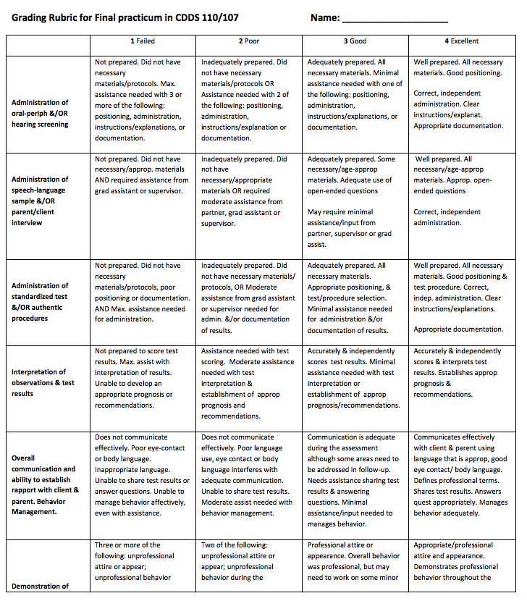

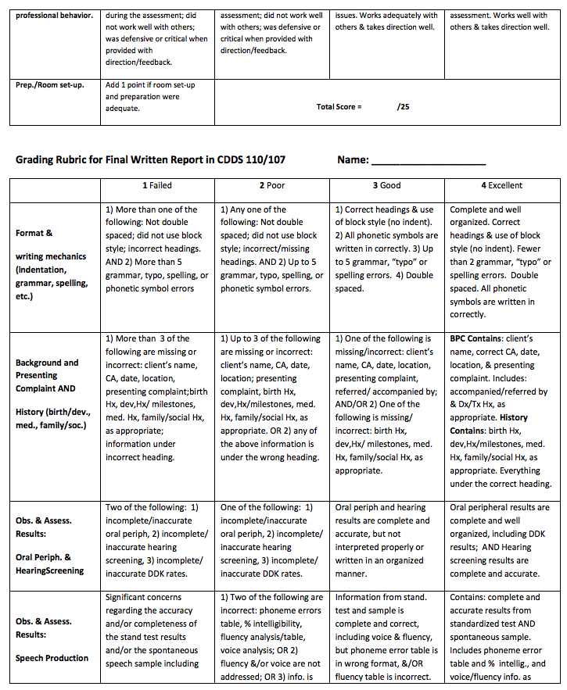

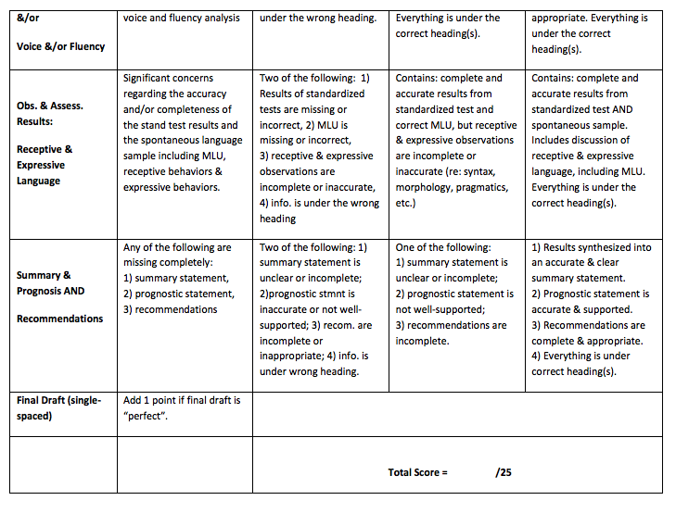

Appendix B: Exit Survey for Undergraduate Students
Our Undergraduate Exit Questionnaire is distributed as an on-line survey using “Qualtrics”. The students respond to each statement using a five point scale: “no opinion”, “strongly agree”, “agree”, disagree”, and “strongly disagree”. It includes the following statements:
1. The program provided me with the skills needed to write a professional report within my discipline.
2. The program provided me with the skills needed to assess an individual’s speech, language, auditory, and communication skills.
3. The program provided me with the skills needed to communicate effectively with potential clients, students, or consumers.
4. The program provided me with the skills needed to demonstrate professional behavior within my discipline.
5. The program provided me with the skills needed to establish appropriate measurable goals for potential clients or students.
6. The program provided me with an understanding of the physical basis for a speech or hearing problem.
7. I completed the requirements needed to apply to a graduate program in my selected field
Note: In addition, the survey contains a narrative area for students to comment on “any areas in the curriculum which affected their level of satisfaction with the program”.

