Annual Assessment Report for 2020-2021 AY
Civil Engineering, B.S.
Reports completed on assessment activities carried out during the 2020-21 AY will be due September 30th 2021 and must be e-mailed to the Director of Assessment, Dr. Douglas Fraleigh (douglasf@csufresno.edu).
Provide detailed responses for each of the following questions within this word document. Please do NOT insert an index or add formatting. Furthermore, only report on two or three student learning outcomes even if your external accreditor requires you to evaluate four or more outcomes each year. Also be sure to explain or omit specialized or discipline-specific terms.
Department/Program: _Civil Engineering_____ Degree _B.S.____
Assessment Coordinator: _Fayzul Pasha, Ph.D., P.E.______________

- Please list the learning outcomes you assessed this year.
Graduates of the Civil Engineering program are expected to achieve the following student learning outcomes.
- An ability to identify, formulate, and solve complex engineering problems by applying principles of engineering, science, and mathematics
- An ability to apply engineering design to produce solutions that meet specified needs with consideration of public health, safety, and welfare, as well as global, cultural, social, environmental, and economic factors
- An ability to communicate effectively with a range of audiences
- An ability to recognize ethical and professional responsibilities in engineering situations and make informed judgments, which must consider the impact of engineering solutions in global, economic, environmental, and societal contexts
- An ability to function effectively on a team whose members together provide leadership, create a collaborative and inclusive environment, establish goals, plan tasks, and meet objectives
- An ability to develop and conduct appropriate experimentation, analyze and interpret data, and use engineering judgment to draw conclusions
- An ability to acquire and apply new knowledge as needed, using appropriate learning strategies.

- What assignment or survey did you use to assess the outcomes and what method (criteria or rubric) did you use to evaluate the assignment? Please describe the assignment and the criteria or rubric used to evaluate the assignment in detail and, if possible, include copies of the assignment and criteria/rubric at the end of this report.
The following tools have been used to evaluate the student learning outcomes (SLO). The assessment tools are classified into two categories: direct and indirect assessment tools. The direct assessment tools include (a) culminating experience, (b) EIT certification at-time-of-graduation, and (c) Body-of-Knowledge score. The indirect assessment tools include (d) student course evaluation survey, and (e) exit interviews. These assessment tools are explained further as follows:

- Culminating experience: Completing a senior design project is the culminating experience for undergraduates in the CE Program curriculum. The senior project experience spans over two semesters. CE180A (2 units) is the first course in the senior design project sequence. The emphasis of CE180A is on design project proposal, project identification, design team formation (i.e., multi-disciplinary), and preliminary development of design alternatives and validations. CE180B is the second course in the senior design project sequence. The emphasis of CE180B is placed on the completion of a major design project initiated in CE180A. Each student in CE180B is paired and supervised by a faculty and a practitioner mentor throughout the entire design process. The deliverables for students in CE180B include progress reports, final project reports, design drawings, and presentations. Oral presentation scoring rubric and the report grading rubric for CE180B are presented in Fig 1 and Fig 2 in the Appendix.
Benchmark
We expect 75% or more of the students enrolled in this class would achieve a 2 (satisfactory) or higher score on presentation and a 2 (average) or higher score on the project binder.
Analysis:
As seen 96% of total students scored 2 or higher in presentation and 98% of the students scored 2 or higher in project binder which are the criteria used for acceptable performance.

Table 1. Percent of students meeting the benchmark
 | Percent of students meeting the benchmark | Percent of students scoring >=3 <=4 | Percent of students scoring >=2 <3 | Percent of students scoring >=1 <2 | Percent of students scoring >=0 <1 | Avg Score | Std Dev.
Presentation | 96% | 84% | 12% | 4% | 0% | 3.30 | 0.59
Project Binder | 98% | 90% | 8% | 0% | 2% | 3.43 | 0.55

- EIT certification at-time-of-graduation: The “Engineer-in-Training” (EIT) is a professional designation from National Council of Examiners for Engineering and Surveying (NCEES) used in the US to designate a person who has passed the 8-hour Fundamentals of Engineering (FE) examination – typically from an ABET accredited engineering program or equivalent. The California licensure Board of Engineers, Surveyors, and Geologists, permits students to take the FE exam prior to their final year. Passage of the FE exam (i.e., EIT certification) qualifies a candidate, as required by the California law, towards becoming licensed as a professional engineer (PE). Even though the Program does not require its students to pass the exam to graduate, passing the exam does signal achievement of certain technical competence by the students. The table and figure below show the percentage of graduating senior passing the exam in last few years.
Benchmark
Following the ABET national passing rate, which generally fluctuates between 60% to 70%, we expect 60% or more of our students enrolled in the FE should pass the exam.
Analysis:
Although the FE passing rates in some semesters are very close to the expectation, the passing rate in general does not meet the benchmark requirement. However, the CE program is working on it to improve the FE passing rate as it is evident by a positive slope of the linear trendline drawn in the figure below.

Table 2. Passing rates in FE
Semester |  | Passing Rate (%) | ABET
Spring | S - 2018 | 50% | 70%
Fall | F - 2018 | 40% | 67%
Spring | S - 2019 | 59% | 69%
Fall | F - 2019 | 52% | 66%
Spring | S - 2020 | 56% | 74%
Fall | F - 2020 | 47% | 64%
Spring | S - 2021 | 59% | 70%
 |  | 52% | 69%

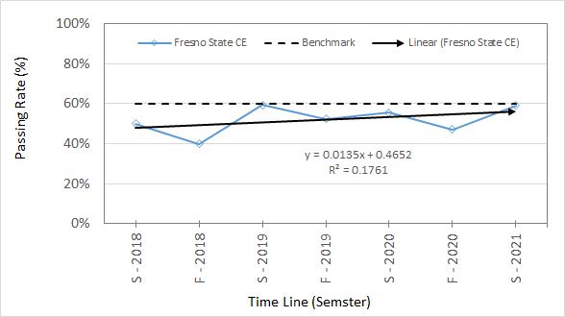
Figure 1. Passing rates in FE compared to benchmark

- Body-of-Knowledge score: The Body of knowledge (BOK) or more accurately the Civil Engineering Body of Knowledge for the 21st Century is a written document published by the American Society of Civil Engineers (ASCE) highlighting the desired knowledge, skills, and attributes to be possessed by a practitioner in civil engineering. The aspiration of BOK is an improved engineering education and tougher requirement for licensure. The BOK is assessed by incorporating or embedding key question(s) in the final examination of selected courses in the CE Program. By correctly answering key question(s), students demonstrate the attainment of specific outcomes in BOK, most of which are consistent with ABET Outcomes. The following table shows the nature of the key questions selected for the assessment.
Table 3. Body-of-Knowledge assessment
Course Number/Title | Nature of BOK Questions | Assessment technique
CE 123: Soil Engineering | Soil classification | One problem in final
CE 128: Civil Engineering Hydraulics | Application of Bernoulli’s principle in fluid dynamics | One problem in final
CE 142: Environmental Engineering | Mass balance & alkalinity | Average of two problems in final
CE 132: Reinforced Concrete Design | Reinforced concrete columns under uniaxial bending | One problem in final
Benchmark
It is expected that at least 70% of the students enrolled in the courses tabulated above will score 70% or better (or 7 out 10 points) on the topics mentioned above in the table.
Analysis:
CE 132 RESULTS AND CONCLUSION: 24 students enrolled in CE132, Spring 2021. 22 out of 24 students (92%) scored better than 70% (performance standard) on the problem; 2 out of 24 students (8%) score worse. In fact, 13 out of 24 students (54%) recorded a perfect score (100% or 10 of 10 points) on this problem. Based on the results, it is concluded that the students satisfied the performance standard and expectation set forth, and thus met student outcomes assessed, SO 1 and SO7.

CE 128 RESULTS AND CONCLUSION: 29 out of 36 students (80%) answered the problem correctly (100% point score). Based on this result, it is concluded that the students satisfied the performance standard and expectation set forth, and thus met student outcomes SO1, SO2 and SO7.

CE 142 RESULTS AND CONCLUSION: 37 students enrolled in CE142 in spring 2021. 34 out of 37 students (92%) participated in the final exam. While 62% of the students who participated in the test earned more than 60% (more than 9 out of 15) on Q3 related to alkalinity, 88% of the students earned more than 60% on Q4 related to mass balance with a resulting average of 74%. Based on the criteria set by the instructor, it is concluded that the students satisfied the performance standard and expectation set forth, and thus met student outcomes SO1 and SO7.

CE 123 RESULTS AND CONCLUSION: There were 10 questions (10 points) on the quiz related to the topic identified in the table shown above. Quiz was administered via MindTap courseware integrated with Canvas learning management system. The questions were mostly conceptual based on the assigned reading. In Section CE123-02, 18 students completed the quiz. All 100% of students in in this section received grades above 70%, with 83% students receiving grades between 90 and 100%. In Section CE123-04, 37 students completed the quiz. Of these students, 97% (36 students) received grades above 70%, while 3% (1 student) received grade less than 70%. Therefore, it is concluded that students satisfied the performance standard and expectation set forth and thus met student outcomes assessed, SO-1

- Student course evaluation survey: A Student Course Evaluation is a survey developed and used by the CE Program to gauge the attainment of specific SOs. The rating system developed by the faculty is used to gauge the student satisfaction, which indirectly indicates the knowledge gained in a course. Fig. 3 in the Appendix shows a sample student course evaluation.
Benchmark
It is expected that the average students rating in each course will be higher than the average expected rating set by the faculty. None of the average expected SOs should have a negative difference of greater than –1.00, which is a criterion for the level of acceptable performance. If any of the measured SOs generates a difference of less than –1.00, then the course could trigger a possible review (the 1st time) by the respective course instructor. If similar SOs incur a difference of less than –1.00 the next time (the 2nd time or beyond), then it could trigger a re-evaluation and/or revision of the course content/delivery and/or re-evaluation of the faculty expectation of the course, as part of the continuous monitoring/improvement process.
Analysis:
Table 4. Student course evaluation survey results
Student Outcomes (SO) | CE 123 |  |  | CE 128 |  |  | CE 132
 | Course Rating (0 to 5) |  |  | Course Rating (0 to 5) |  |  | Course Rating (0 to 5)
 | Faculty Expect. | Student Eval. | Diff. | Faculty Expect. | Student Eval. | Diff. | Faculty Expect. | Student Eval. | Diff.
SO 1 | 5.00 | 4.46 | -0.54 | 5.00 | 4.42 | -0.58 | 5.00 | 4.00 | -1.00
SO 2 | 4.00 | 4.56 | 0.56 | 4.00 | 4.65 | 0.65 | 5.00 | 4.30 | -0.70
SO 3 | 3.00 | 4.10 | 1.10 | 3.00 | 4.62 | 1.62 | 3.00 | 3.30 | 0.30
SO 4 | -N/A- |  |  | -N/A- |  |  | -N/A-
SO 5 | 4.00 | 4.20 | 0.20 | -N/A- |  |  | 3.00 | 3.50 | 0.50
SO 6 | 5.00 | 4.37 | -0.63 | -N/A- |  |  | -N/A-
SO 7 | 3.00 | 4.49 | 1.49 | 4.00 | 4.69 | 0.69 | 3.00 | 4.00 | 1.00
Average | 4.00 | 4.36 | 0.36 | 4.00 | 4.60 | 0.48 | 3.80 | 3.82 | 0.02
Instructor’s notes/summary:

 | 1. Overall, students give higher rating (4.36) than faculty expectation (4.00) |  |  | 1. Overall, students give higher rating (4.60) than faculty expectation (4.00) |  |  | 1. Overall, students give higher rating (3.82) than faculty expectation (3.80)
 | 2. Maximum positive difference of this course = +1.49 (Q7) |  |  | 2. Maximum positive difference of this course = +1.62 (Q3) |  |  | 2. Maximum positive difference of this course = +1.00 (Q7)
 | 3. Maximum negative difference of this course = –0.63 (Q6) |  |  | 3. Maximum negative difference of this course = –0.58 (Q1) |  |  | 3. Maximum negative difference of this course = –1.00 (Q1)
 | 4. None of the expected SOs has a negative difference of greater than –1.00, which is a criterion for the level of acceptable performance. |  |  | 4. None of the expected SOs has a negative difference of greater than –1.00, which is a criterion for the level of acceptable performance. |  |  | 4. None of the expected SOs has a negative difference of greater than –1.00, which is a criterion for the level of acceptable performance.

- Exit interviews: The exit interview is an opinion survey of graduating students to gauge the attainment of specific SOs. The survey is a snap-shot of opinions of graduating students regarding the established SOs.
Benchmark
It is expected that the average students rating in exit survey will be higher than the average expected rating set by the faculty. None of the average expected SOs should have a negative difference of greater than –1.00, which is a criterion for the level of acceptable performance. If any of the measured SOs generates a difference of less than –1.00, then the course could trigger a possible review (the 1st time) by the respective course instructor. If similar SOs incur a difference of less than –1.00 the next time (the 2nd time or beyond), then it could trigger a re-evaluation and/or revision of the course content/delivery and/or re-evaluation of the faculty expectation of the course, as part of the continuous monitoring/improvement process.

Analysis:
Table 5. Exit survey results
Student Outcomes (SO) | Fall 2020 |  |  | Spring 2021
 | Course Rating (0 to 5) |  |  | Course Rating (0 to 5)
 | Faculty Expectation | Student Evaluation | Difference | Faculty Expectation | Student Evaluation | Difference
SO 1 | 5.00 | 4.83 | -0.17 | 5.00 | 4.91 | -0.09
SO 2 | 5.00 | 4.09 | -0.91 | 5.00 | 4.00 | -1.00
SO 3 | 4.00 | 4.41 | 0.41 | 4.00 | 4.55 | 0.55
SO 4 | 4.00 | 4.48 | 0.48 | 4.00 | 4.73 | 0.73
SO 5 | 3.00 | 4.48 | 1.48 | 3.00 | 4.82 | 1.82
SO 6 | 3.00 | 4.48 | 1.48 | 3.00 | 4.55 | 1.55
SO 7 | 3.00 | 4.65 | 1.65 | 3.00 | 4.82 | 1.82
Average | 3.86 | 4.49 | 0.63 | 3.86 | 4.62 | 0.77
Instructor’s notes/summary:

 | 1. Overall, students give higher rating (4.49) than faculty expectation (3.86) |  |  | 1. Overall, students give higher rating (4.62) than faculty expectation (3.86)
 | 2. Maximum positive difference of this course = +1.65 (Q7) |  |  | 2. Maximum positive difference of this course = +1.82 (Q5 & Q7)
 | 3. Maximum negative difference of this course = –0.91 (Q2) |  |  | 3. Maximum negative difference of this course = –1.00 (Q2)
 | 4. None of the expected SOs has a negative difference of greater than –1.00, which is a criterion for the level of acceptable performance. |  |  | 4. None of the expected SOs has a negative difference of greater than –1.00, which is a criterion for the level of acceptable performance.

- What did you learn from your analysis of the data? Please include sample size (how many students were evaluated) and indicate how many students (number or percentage instead of a median or mean) were designated as proficient.

All together approximately 323 students were evaluated. Assessment analysis show the program is moving towards the right direction to achieve the student learning outcomes. However, program plans to complete the assessment for other courses including lab courses before a final conclusion can be made. Analysis also finds that there is a scope to improve the FE passing rate. Although the program does not require student pass FE exam but it can be a good indicator to assess the learning outcomes.

- What changes, if any, do you recommend based on the assessment data?

As the program is moving in the right direction in terms of student learning outcomes there is no need to change in the courses assessed. However, there are other courses that need to be assessed before a final conclusion can be made. For the FE exam, several steps can be taken to improve the passing rates which include;
- Promoting the value of FE and motivating students to take the FE and become EIT by the time they graduate;
- Including FE exam type questions in senior design classes;
- Offering prep workshops in the weekends;
- Planning to prepare students incrementally, by including some of the FE type questions in the critical courses. Incremental preparation in multiple courses will help students learn the subject better.
- Planning to develop FE awareness campaign including panel presentations by senior engineers and recent graduates
- Including local civil engineering firms for logistics and sustainability for the FE awareness campaign and success in FE.

- If you recommended any changes in your response to Question 4 in last year’s assessment report, what progress have you made in implementing these changes? If you did not recommend making any changes in last year’s report please write N/A as your answer to this question.

N/A, as there was no report due last year

- What assessment activities will you be conducting during the next academic year?

Similar activities including FE and exit survey and the BOK assessment and student survey for the courses identified in the SOAP.

- Identify and discuss any major issues identified during your last Program Review and in what ways these issues have or have not been addressed.
No program weakness or concern or issue was identified during AY2018-19 national accreditation (i.e., ABET) review or in the subsequent (internal) University review; therefore, no corrective action for the program is planned or implemented.

Appendix
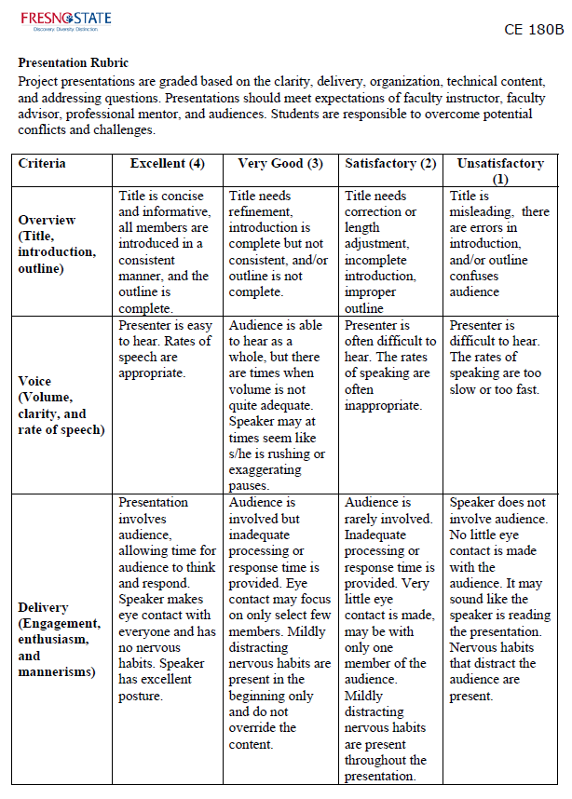
Fig. 1. Oral presentation rubric for CE180B.
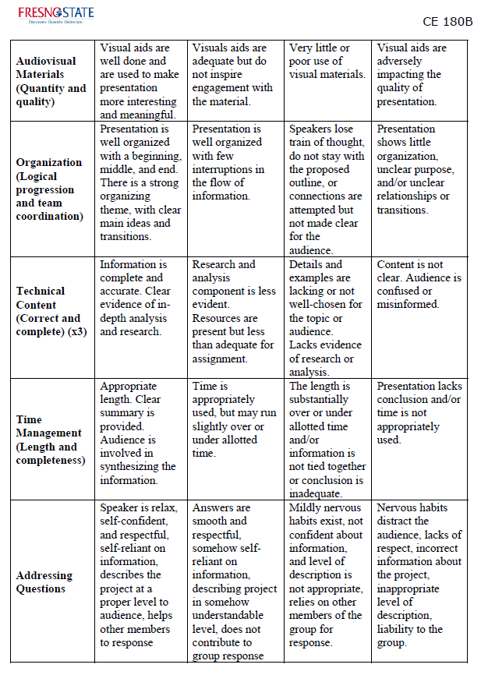
Fig. 1 (Cont’d). Oral presentation rubric for CE180B.

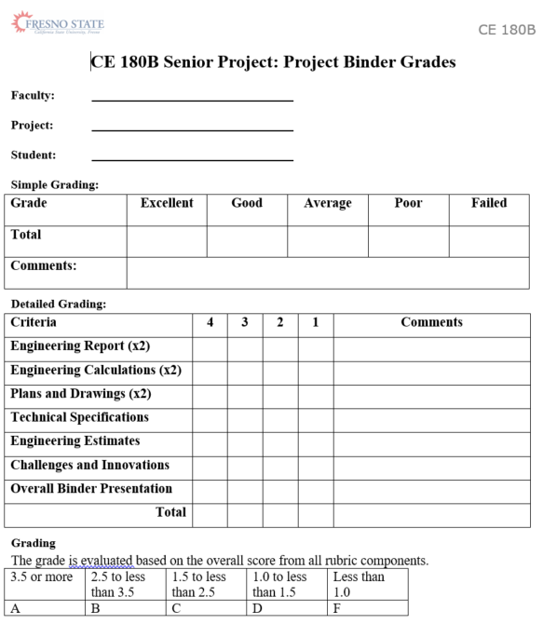

Fig. 2. Binder grading rubric for CE180B.

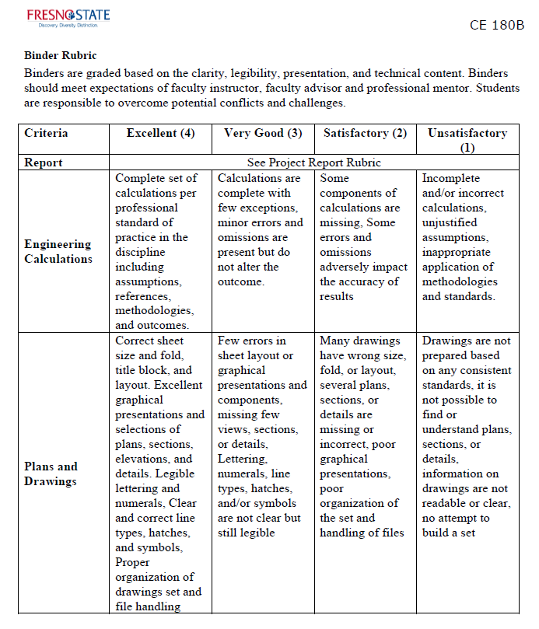
Fig. 2 (Cont’d). Binder grading rubric for CE180B.

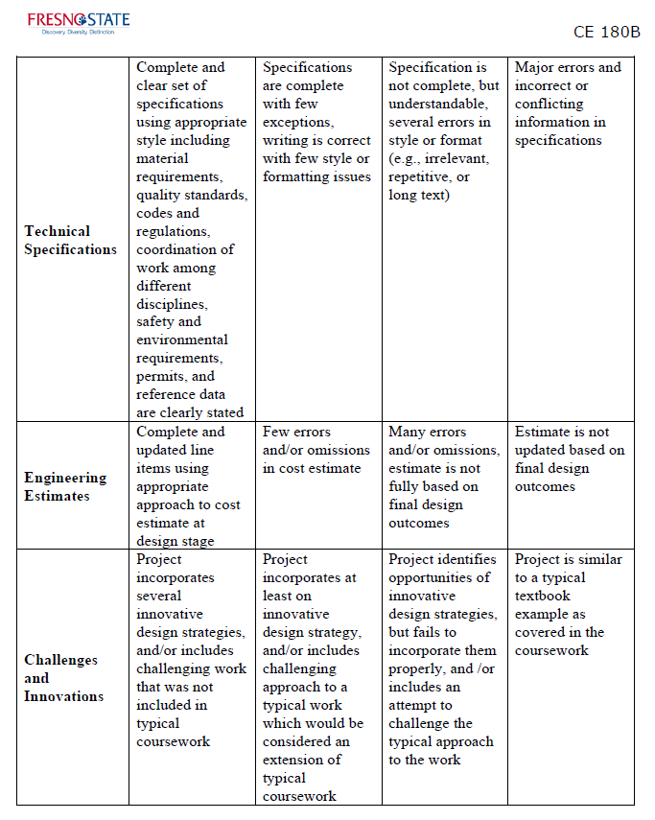
Fig. 2 (Cont’d). Binder grading rubric for CE180B.

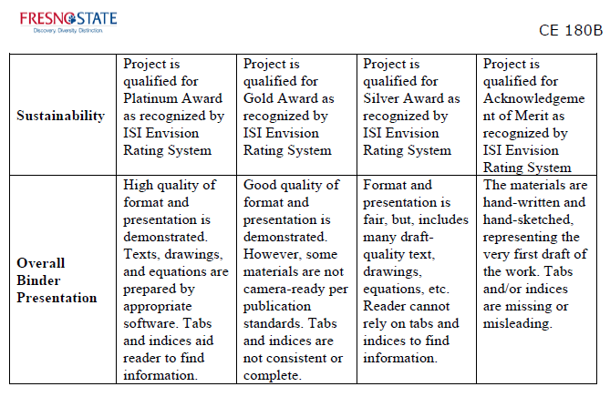
Fig. 2 (Cont’d). Binder grading rubric for CE180B.

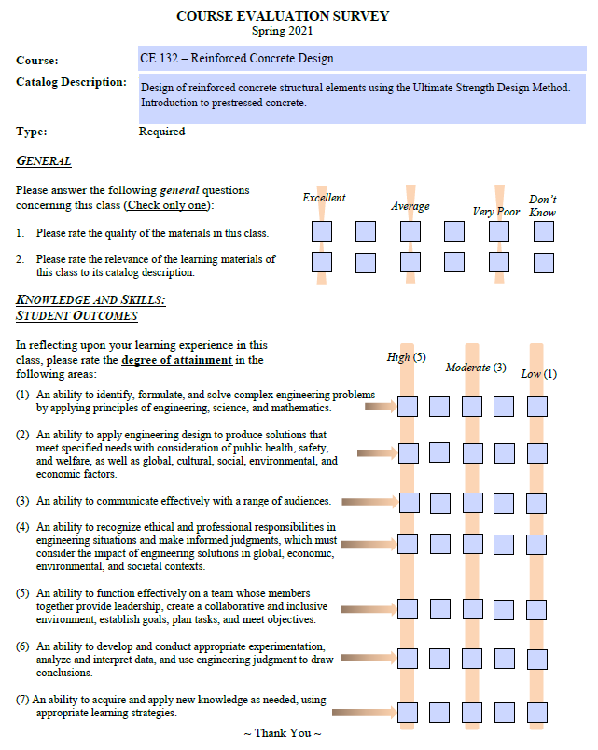
Fig. 3. Sample student course survey

ASCE, Civil Engineering Body of Knowledge for the 21st Century (2nd Edition), 2008

