Annual Assessment Report for 2020-2021 AY
Reports completed on assessment activities carried out during the 2020-2021 AY will be due September 30th 2021 and must be e-mailed to the Director of Assessment, Dr. Douglas Fraleigh (douglasf@csufresno.edu).
Provide detailed responses for each of the following questions within this word document. Please do NOT insert an index or add formatting. For purposes of this report, you should only report on two or three student learning outcomes (department’s choice) even if your external accreditor requires you to evaluate four or more outcomes each year. Also be sure to explain or omit specialized or discipline-specific terms.

Department/Program: Educational Leadership/Doctoral Program in Educational Leadership Degree: Ed.D.
Assessment Coordinator: Ignacio Hernández

- Please list the learning outcomes you assessed this year.

Program Learning Outcome 2: Be competent to play a key role in leading educational reform related to instructional practices and policies, educator professional development and support, curriculum, and community relations, and home, school and college learning environments.
SOAP (link)

- What assignment or survey did you use to assess the outcomes and what method (criteria or rubric) did you use to evaluate the assignment? Please describe the assignment and the criteria or rubric used to evaluate the assignment in detail and, if possible, include copies of the assignment and criteria/rubric at the end of this report.

The program used the Qualifying Exam (QE) to assess PLO #2. The QE was also referenced in program review recommendation #6.
The QE is a problem-based case study scenario that is administered after students complete the nine (9) core courses of the Ed.D. curriculum. The QE is meant to gauge how well students are able to demonstrate their learning of the core course content in relation to problem-based scenarios in educational leadership. This is consistent with Executive Order 991 issued by the CSU Office of the Chancellor. Specifically, Article 7.1.1 states, “The qualifying examination shall include a rigorous written assessment of student knowledge; the examination must be passed prior to the student’s advancement to candidacy.”

Student Work
The nine core courses are organized around three competency areas 1) applied research and evaluation, 2) cross-cultural leadership, and 3) organizational leadership
Students are expected to work on their own to provide comprehensive written responses for the three competency areas. Student responses should answer the questions from each prompt and should be guided by the problem-based case study. Students’ responses should demonstrate their knowledge base, critical thinking, and writing skills as a reflective leader-scholar. This an individual exam and not group work. All aspects of the QE are administered via Canvas.
Student Preparation
The goal of this examination is for students to demonstrate their ability to integrate the learning experienced in the core courses and related fieldwork experiences. Specific skills, knowledge, and learning outcomes provided in any one course have already been assessed as part of that class. As a result, the QE is designed to provide a forum for the integration of learning and demonstrated mastery of content relative to a case study scenario. Demonstrated mastery of the core coursework is the key to success in this process. It will be reiterated that students are not being re-graded for classes they have already completed.
- What did you learn from your analysis of the data? Please include sample size (how many students were evaluated) and indicate how many students (number or percentage instead of a median or mean) were designated as proficient. Also indicate your benchmark (e.g. 80% of students will be designated as proficient or higher) and indicate the number of students who met that benchmark.
The QE was administered to 41 students in January 2021. Each submission was scored by two reviewers. Overall, 31 students passed all portions of the QE with 10 students needing to revise and resubmit one or more portions. The table and chart below provide a summary.
Pass | 31 | 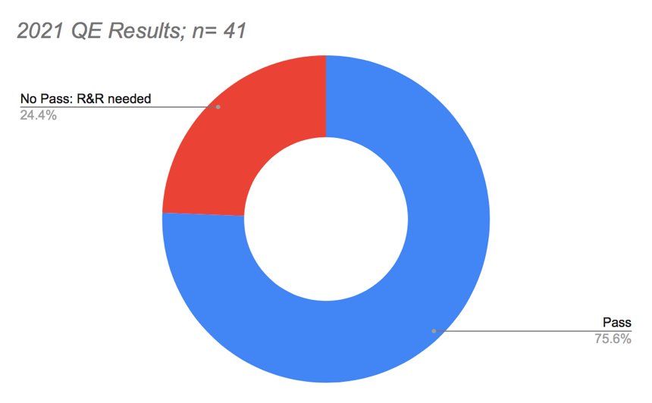
No Pass: R&R needed | 10
Total | 41

Students had two weeks to revise and resubmit and were directed to make an appointment with the Graduate Writing Studio to work on their revisions. Original reviewers were asked to review the 10 students' revised submissions. Program staff managed student inquiries and reached out to faculty first before referring student to them. The 10 initial non-passing QE submissions were revised and resubmitted. All 10 subsequently passed and advanced to candidacy.

- What changes, if any, do you recommend based on the assessment data?
Feedback meetings with students and faculty were held following the QE. Students shared recommendations for changing the QE process. A student preparation guide was recommended by students and faculty.

- If you recommended any changes in your response to Question 4 in your 2018-19 assessment report, what progress have you made in implementing these changes? If you did not recommend making any changes in last year’s report, please write N/A as your answer to this question.

An updated student preparation guide has been drafted with input from the course instructors of the nine core courses of the Ed.D. curriculum.
A student-led workshop will be held in October 2021 to help the students who will take the QE in January 2022.

- What assessment activities will you be conducting during AY 2021-22?
The program will focus on Program Learning Outcome 4:
Design and execute applied studies related to effective educational institutions, best- practices, leadership and student success.
As a direct measure, a fieldwork rubric will be refined and applied to course-level assessment of student learning. This is anticipated to take place in EDL 506-Conceptual Curriculum Perspectives for Educational Leadership during Spring 2022. As an indirect measure, a questionnaire will be developed. The questionnaire will collect data about student perceptions of their learning as well as the program’s embedded fieldwork signature pedagogy. Results of these measures will help the program refine its understanding of the role and purpose of embedded fieldwork. This is consistent with program review recommendation #2.

- Identify and discuss any major issues identified during your last Program Review and in what ways these issues have or have not been addressed.

An external review panel conducted a Program Review of the Doctoral Program in Educational Leadership on November 18, 2019. That report resulted in seven (7) recommendations. Recommendation #6 provided the basis for using the QE to assess PLO #2

- As the program is going through a process of renewal, they should explore conventions of the dissertation and communicate what common criteria would characterize a Fresno dissertation for rigor and philosophical grounding. The program should consider allowing more time for dissertation development and execution.

- Curriculum review and revision should continue as planned, but also include considering sequencing of courses to move content courses out of the dissertation year. As they on-board a new faculty, they should make sure that all teaching faculty know the full curriculum to enhance alignment and reinforce key concepts from course to course.

- The EDD budget runs with significant carry over each year, while simultaneously not reflecting the actual cost of the program. Budgeting should be revised to reflect the cost of instruction and other programmatic needs to make for a more transparent use of student funds. A fully transparent budgeting process would allow for program leadership to strategically use student tuition funds to meet their needs and would allow the college to recoup funds from non-Educational Leadership instruction that might help in meeting college financial needs. In this process, if needed, reconsider faculty compensation for 3-unit classes and other forms of compensation as they may be above CSU EDD program norms.

- All planned assessment activities reviewed and/or revised and carried out as planned going forward. When reporting on the SOAP and other program documents, all assessment language should refer to or align to program outcomes and clearly indicate when data will be collected. Regular collection of alumni and employer data will help the program to more be more agile in meeting leadership needs of its constituent groups.

- Consistently update student data to include retention rates, time to degree, student demographic characteristics, report them on an annual basis, and use them in the recruitment of new students.

- Continue to examine the purpose, the format and the timing of the qualifying exam to facilitate leadership development and/or dissertation development, as seems as if students and faculty were not in consensus on the purpose of the exam.

7. Reconstitute the Advisory Board, as planned, attending to community involvement and balancing representation between higher education and PK-12.

