Annual Assessment Report for 2020-2021 AY
Reports completed on assessment activities carried out during the 2020-21 AY will be due September 30th 2021 and must be e-mailed to the Director of Assessment, Dr. Douglas Fraleigh (douglasf@csufresno.edu).
Provide detailed responses for each of the following questions within this word document. Please do NOT insert an index or add formatting. Furthermore, only report on two or three student learning outcomes even if your external accreditor requires you to evaluate four or more outcomes each year. Also be sure to explain or omit specialized or discipline-specific terms.

Department/Program: MCLL/ French
Degree: French BA
Assessment Coordinator: Dr. Tara Hashemi

- Please list the learning outcomes you assessed this year.
For the AY 2020-2021, we assessed outcomes A1, A4 and A5 in the French 150: Advanced Conversation class (taught online due to the Covid 19 pandemic). According to our SOAP, students should have mastered these three learning outcomes when they are taking this course:
A1: Appropriately communicate orally, and orally express ideas, both academic and every day, coherently and critically in French.
A4: Use several strategies for vocabulary expansion/acquisition in topical/semantic areas.
A5: Demonstrate accurate reading comprehension of material of a cultural and/or literary nature.

- What assignment or survey did you use to assess the outcomes and what method (criteria or rubric) did you use to evaluate the assignment? Please describe the assignment and the criteria or rubric used to evaluate the assignment in detail and, if possible, include copies of the assignment and criteria/rubric at the end of this report.

- Students were assigned a document including a text in French, five to ten questions on the text, and important vocabulary to remember (see appendix 3) -> A5
- After getting familiarized with the text and questions, students were assigned to a conversation group where they would hold the role of “the leader.” The leader is in charge of leading the conversation, communicate orally while expressing ideas coherently and critically in French. (appendix 2) -> A1
- The leader should also serve as an “expert” in the presented vocabulary and use it during the conversation (appendix 2) -> A4

Appendix 1 shows the rubric used to assess students’ work

- What did you learn from your analysis of the data? Please include sample size (how many students were evaluated) and indicate how many students (number or percentage instead of a median or mean) were designated as proficient.
The data included 5 students and 100% were designated as proficient.

- What changes, if any, do you recommend based on the assessment data?
It is difficult to assess the reliability of our data since it is based on a course that was taught under very special circumstances (Spring 2021 was only our second full semester during the covid 19 pandemic). We did however draw some lessons from it: assigning students with a specific role (such a leader) in conversation assignment augmented their motivation and sense of responsibility. In the future, that is an aspect we would like to keep no matter what the teaching modalities are.

- If you recommended any changes in your response to Question 4 in last year’s assessment report, what progress have you made in implementing these changes? If you did not recommend making any changes in last year’s report please write N/A as your answer to this question.
Unfortunately, FREN150 has not been taught since the Spring of 2021. We do however plan on, as cited above, assign students with specific roles in conversation assignments since it has proven to be highly efficient.

- What assessment activities will you be conducting during the next academic year?

During the next academic year, and in the context of having enough students to be able to offer a FREN150 course, we will be assessing the same SLOs but in a face to face format.

- Identify and discuss any major issues identified during your last Program Review and in what ways these issues have or have not been addressed.

Our previous program review mentioned the creation of “a new French and Francophone minor that better address today’s student’s needs, such the need for French for Professional Purposes.” We have successfully created that minor and have been and have indeed included quality materials for our courses and develop better scaffolding between courses and levels of French to achieve our student learning outcomes.
One big challenge we will be facing these upcoming semesters is our enrollment numbers which, while not affecting assessment per say, does affect our ability to provide a reliable program assessment due to lack of data.

APPENDIX

Appendix 1:
Nom : Date :
Your Presentational Communication (Speaking) will be assessed with the following rubric:

 | Excellent | Satisfactory | Needs Improvement | Unacceptable
 | 3 | 2 | 1 | 0
CONTENT
 | All requested information is provided | Some requested information is provided | Only part of the information is provided | The information requested is not provided
ORGANIZATION
Flow | Related ideas are always or almost always grouped together/ flow together | Related ideas are usually grouped together/ flow together most of the time | Related ideas are occasionally grouped together/ flow together | Related ideas are rarely/ never grouped together/ flow together
LANGUAGE & STYLE
Grammar | Grammar is always or almost always accurate | Grammar is usually accurate | Grammar is occasionally accurate | Grammar is rarely/ never accurate
Vocabulary & Register | Vocabulary is always or almost always varied and appropriate; register is appropriate for character | Vocabulary is usually varied and appropriate; register is appropriate for character | Vocabulary is occasionally varied and appropriate; register is not appropriate for character | Vocabulary is rarely/ never varied and appropriate; register is not appropriate for character
PRONUNCIATION & FLUENCY
Comprehensibility | Intended message is always/ almost always comprehensible | Intended message is usually comprehensible | Intended message is occasionally comprehensible | Intended message is rarely/ never comprehensible
Pronunciation | Chapter expressions are always/ almost always accurately pronounced | Chapter expressions are usually accurately pronounced | Chapter expressions are occasionally accurately pronounced | Chapter expressions are rarely/ never accurately pronounced
Fluency | Speech is always/ almost always fluent (without long pauses) | Speech is usually fluent | Speech is occasionally fluent | Speech is rarely/ never fluent
DELIVERY
Audibility | Words are always/ almost always clear & audible | Words are usually clear & audible | Words are occasionally clear & audible | Words are rarely/ never clear & audible
TOTAL POINTS: ___________/ 24
COMMENTS:

Appendix 2:

Assignment:
Every week, you will have a group zoom discussion with a moderator.
Before meeting online for the group discussion ALL STUDENTS have to read and learn the vocabulary in that week's text (click here)
This week's groups are:
 | Groupe 1 | Groupe 2
MODERATEURS | S | Ma
 | E | E
 | J | H
 | T | D

MODERATORS:
Moderators will be in charge of:
- Choosing a date and a time that is convenient to all their group members using https://doodle.com/create (Links to an external site.) (see students’ emails below). DONE BY TUESDAY
- Creating and sending a Zoom invitation to their group members (see here for how to https://www.howtogeek.com/661924/how-to-set-up-a-zoom-meeting/ (Links to an external site.) ) (DONE BY WEDNESDAY)
- Record the Zoom conversation https://www.businessinsider.com/how-to-record-zoom-meeting?IR=T (Links to an external site.) (YOU HAVE UNTIL SUNDAY)
- Post the Zoom conversation on Canvas (post it here). (DUE SUNDAY)
Moderators will receive two grades: a zoom discussion grade and a moderator grade. A good moderator should be able to lead the zoom conversation by asking questions, asking for clarification or follow up comments. Moderators are NOT in charge of correcting students but can make suggestions should they want to.

Appendix 3

DOCUMENT DÉCLENCHEUR

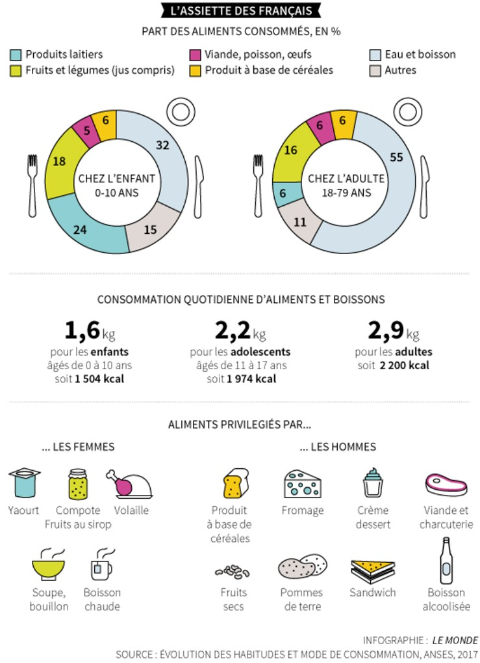
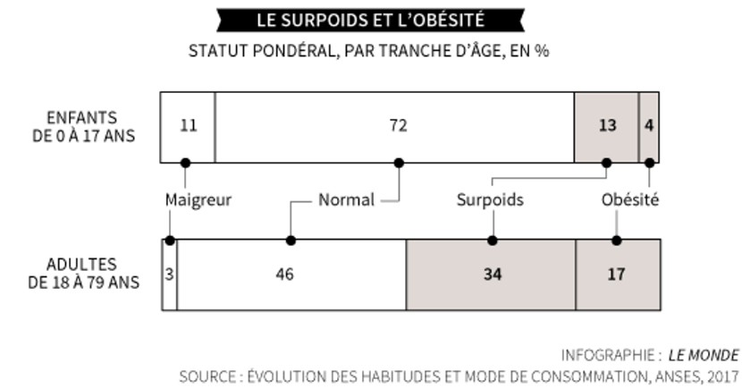
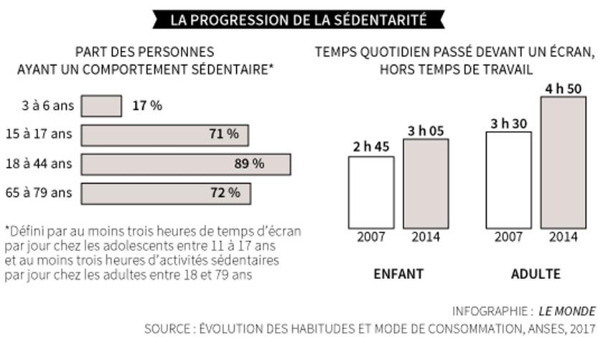
Les Français mangent mal et se sédentarisent
Selon une vaste étude de l’Anses, les assiettes contiennent toujours plus de produits transformés et de compléments alimentaires, trop de sel et pas assez de fibres.

Inégalités sociales
L’analyse du poids des Français et de leur alimentation met au jour de fortes disparités de sexe, d’âge ou de région. Les adultes de 65 à 79 ans consomment par exemple plus d’aliments faits maison, les hommes de denrées animales crues, et les habitants des grandes agglomérations de poissons, confiseries et jus de fruits.
Mais ce sont surtout les inégalités sociales qui s’avèrent les plus criantes. Les Français ayant un niveau d’étude supérieur ou égal à bac + 4 consomment davantage de fruits et deux fois moins de sodas que ceux qui se sont arrêtés au primaire ou au collège. Ils pratiquent plus d’activité physique et sont moins souvent obèses. « Cette étude confirme que la nutrition est un grand marqueur social, juge Serge Hercberg. Ces inégalités ont tendance à s’accroître : les populations défavorisées améliorent leur état nutritionnel mais beaucoup moins vite et moins nettement que celles favorisées. »
Audrey Garric, Le Monde, 12/07/2017
http://www.lemonde.fr/planete/article/2017/07/12/les-francais-mangent-mal-et-se-sedentarisent_5159458_3244.html

PROPOSITIONS DE QUESTIONS

- Quel est le problème soulevé dans ce document ?
- De quoi est constituée l’assiette des Français ? Et dans votre pays ?
- Comment peut-on expliquer l’évolution de l’alimentation des Français ?
- Pouvez-vous expliquer l’augmentation de la sédentarité ?
- Quelle est la relation entre l’alimentation et la classe sociale ? Comment pouvez-vous l’expliquer ?
- Connaissez-vous des mesures mises en place en France pour lutter contre la malbouffe ?
- Quelles solutions pouvez-vous proposer ?

Proposition de devoir : Rédiger un court article sur l’alimentation dans votre pays. (100 mots)
LEXIQUE

- Une assiette
- Se sédentariser
- Un produit transformé
- Le sel
- Les fibres (fem.)
- Une inégalité sociale
- L’alimentation (fem.)

